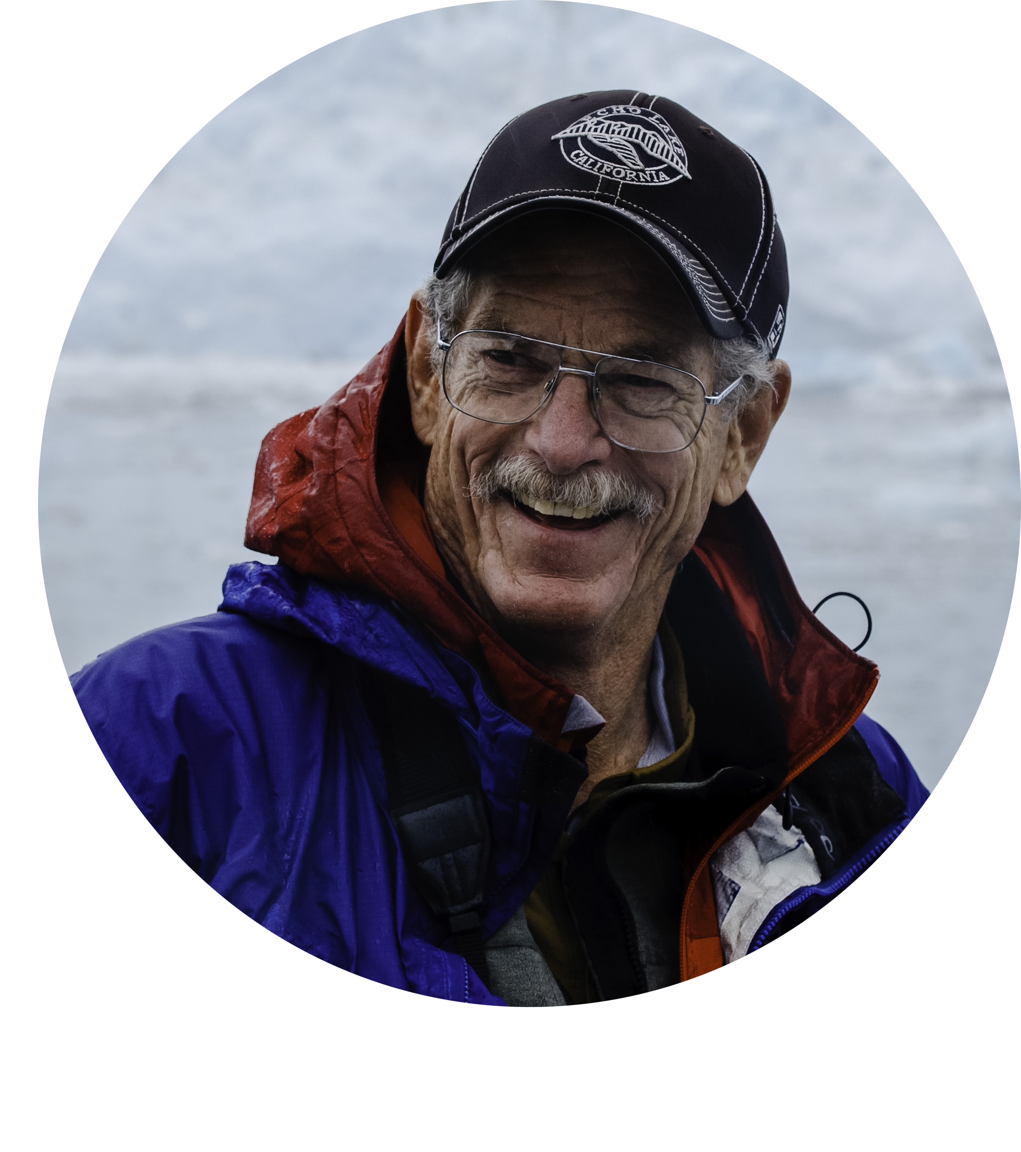
Dan Holmes
The Elusive Landscape
Powerful and Emotional Landscape Photography.

Dan Holmes travels the world exploring, discovering, and telling stories with light. He is a top tier landscape and nature photographer, with national and international awards. He teaches photography and leads photo workshops in Alaska, Nepal, Bhutan, Namibia, Bolivia/Chile and California.

Dan is past President of the Channel Islands Professional Photographers Association, a Fellowship member of Professional Photographers of California, and is a PPC California Master Photographer. He is a PPC Certified Image Competition judge, and has spoken to and judged for a wide variety of photographic groups, both regional and international.

Dan’s awards include PPC 2x Landscape, Nature & Photojournalist Photographer of the Year; Kodak Gallery Award; five-time PPC Top Ten Photographer, Black and White Spider International, Creative Asia and others. He has been published in Outdoor Photographer, ProPhoto West, Landscape Magazine, Digital Photographer, Outside Magazine, Runner’s World, Cycling News, and is represented by Getty Images, and Premier Artists Collection.

