March 11, 2019 Beer Booth Committee Update:
The Beer Booth Committee Guidelines approved by the Club Presidents of the respective Yolo County Rotary clubs in 2015 specify that the Chair, Assistant Chair, Secretary and Treasurer will be nominated/elected each year by the Beer Booth Committee members in Jan each year. Elections are planned for late March/early April this year.
The Guidelines state that 5% of each year’s net profit will be held back in a reserve fund for future projects and expenditures in excess of $200 requires a committee vote. The 5% holdback was approved for a three year period, with a stipulation that it would be revisited in 2018 and the guidelines amended as deemed appropriate at that time. Recommendations on extending the holdback and other modifications to the guidelines will be developed for consideration/vote by the Committee (after consultation between Club Presidents and Committee members as per the guidelines). The next (last?) anticipated improvement projects include lighting and a shade structure for the seating area in front of the band stand trailer location.
The following is a summary financial report back to 2015 when the reserve concept was implemented.
Funding to Clubs Rotary Park Project Funding
 | income | expense | Gross Proceeds | less 5% reserve | total to clubs | 5% reserve | tips | Total | project expenses
2015 | $87,784 | $50,819 | $36,965 | $1,848 | $35,100 | $1,848 | $1,498 | $3,346 | $0
2016 | $87,187 | $48,533 | $38,654 | $1,933 | $36,900 | $1,933 | $1,254 | $3,187 | $0
2017 | $87,029 | $51,534 | $35,495 | $1,775 | $34,000 | $1,775 | $1,007 | $2,782 | $0
2018 | $98,093 | $55,814 | $42,279 | $2,114 | $40,000 | $2,114 | $1,346 | $3,460 | $10,250 | pavers
 |  |  |  | total | $146,000 | total |  | $12,775 | $10,250

A Beer Booth Committee webpage (see next page/link below) was initiated in 2015/16 as a repository of information related to the committee operations, including committee member directory, committee positions, contact information, the Operating Guidelines and Procedures, meeting agendas, minutes, and financial reports. It is accessible at http://www.woodlandrotary.org/BeerBooth.cfm It is in the process of being updated . Direct suggestions/questions to Gary Wegener 530 908 4914
Pending Committee Meetings.
March 18th: Stress transparency in what we do. Post meeting agendas and minutes; better financial reporting; better definition, approval process and reporting on projects. Review, update, and follow the committee guidelines. Confirmation of committee members. Nominations for committee positions (Chair, Co-chairs, secretary, treasurer, webmaster, subcommittee members).
8 April: Election for committee positions. Discuss plans for August fair beer booth operation (need for delegating responsibilities) and suggested changes to Guidelines.

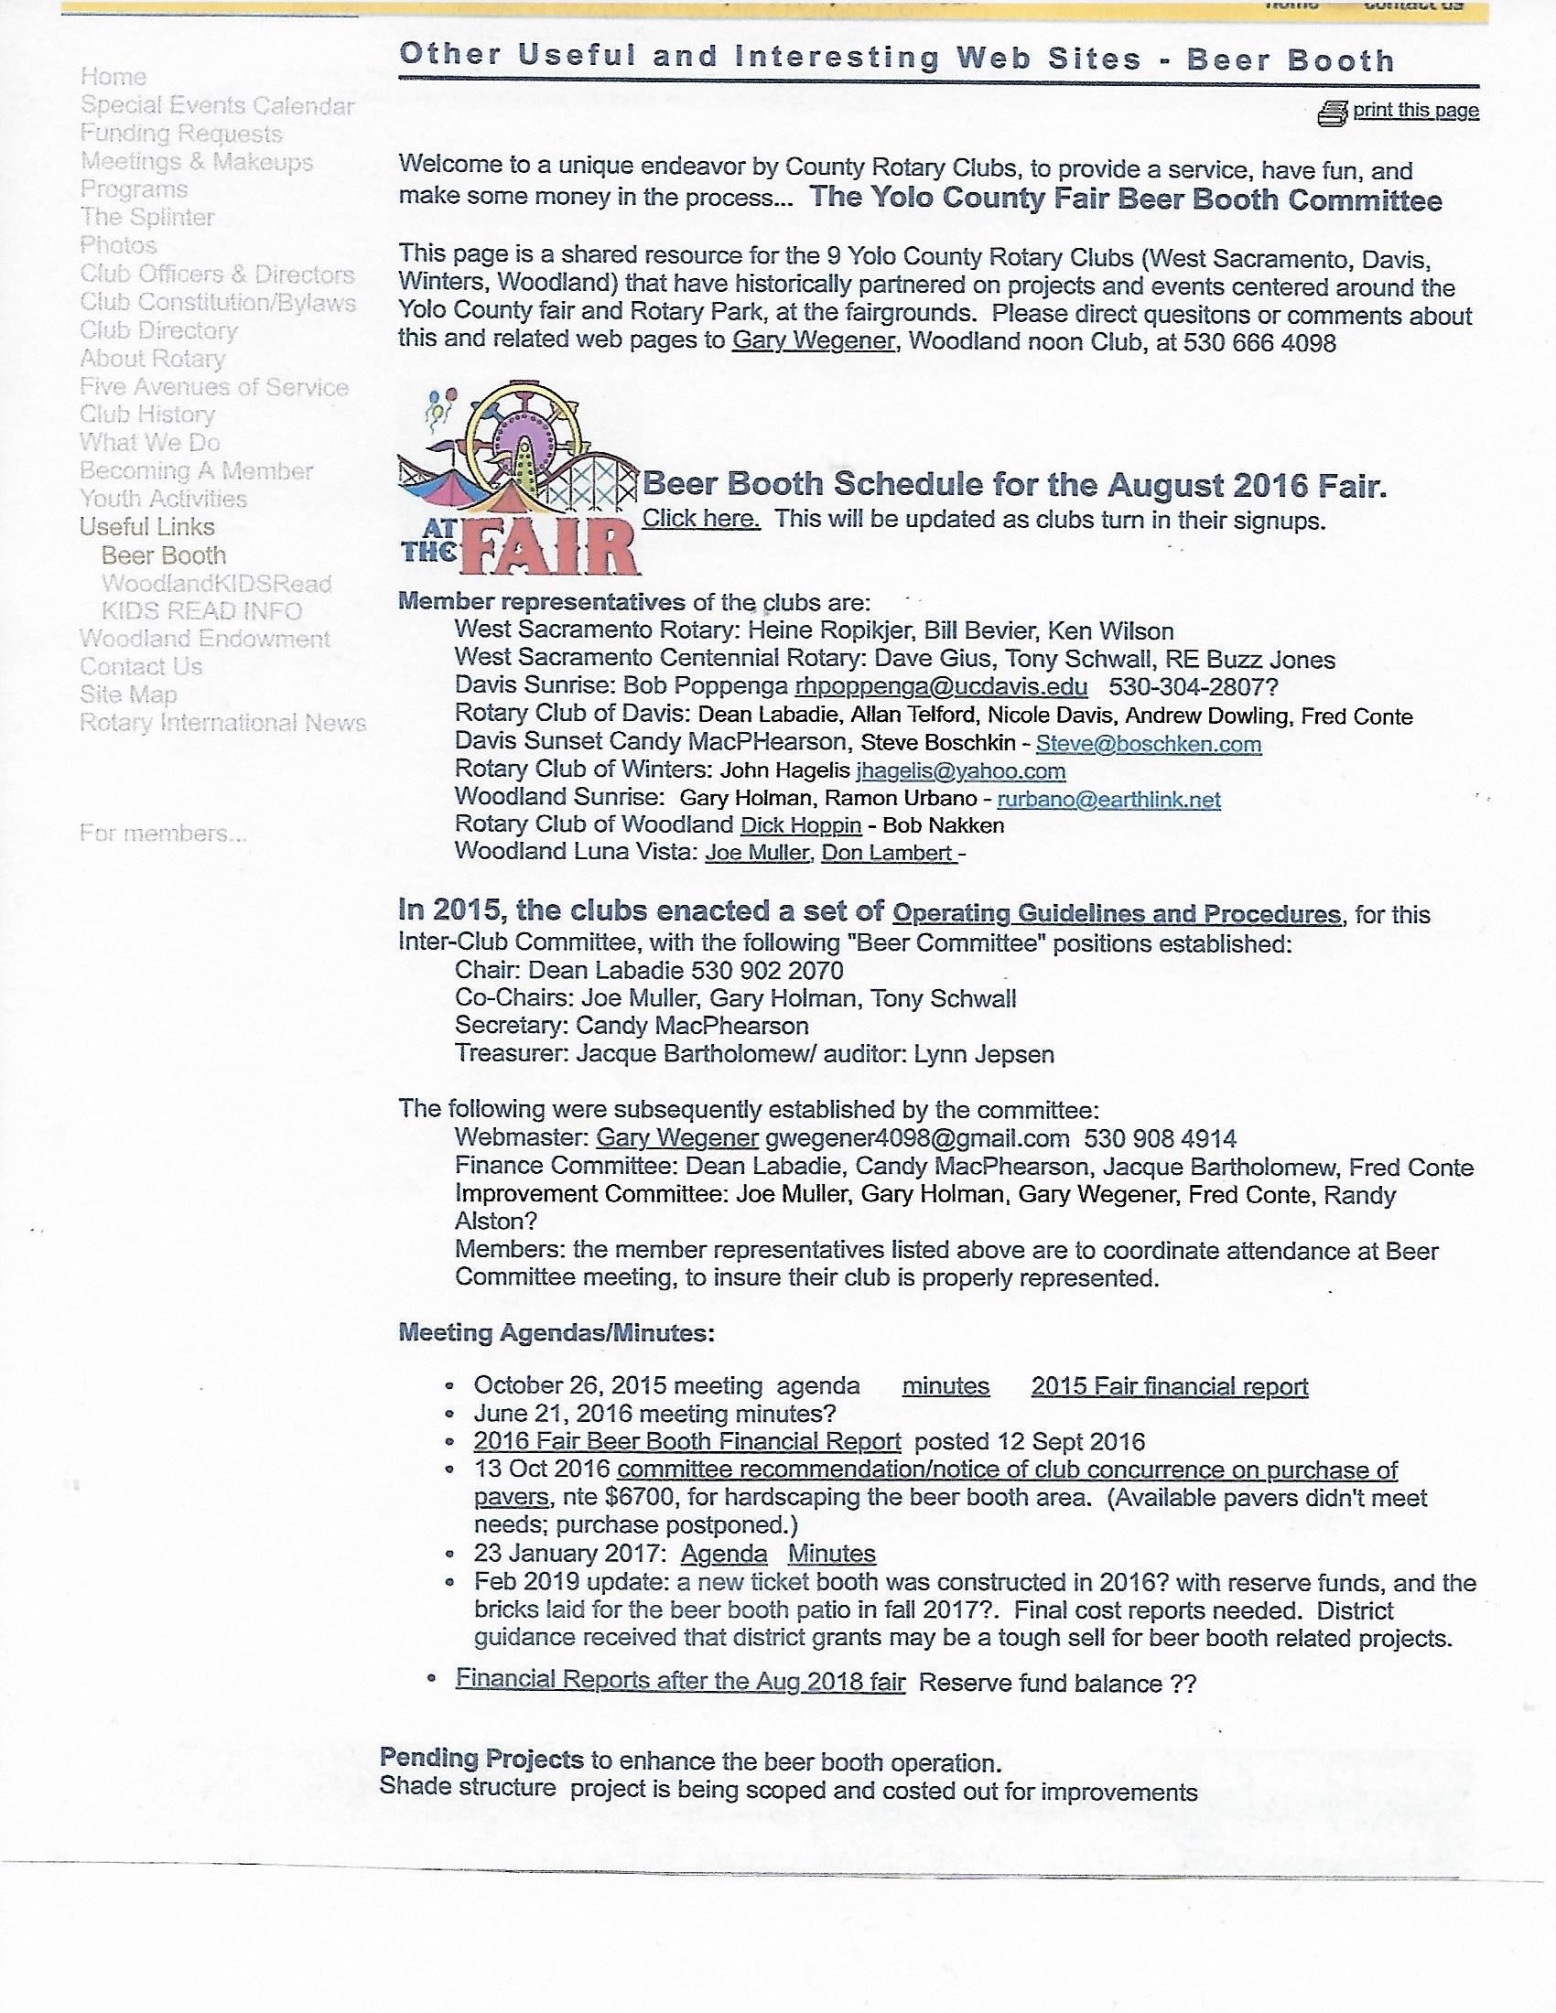
http://www.woodlandrotary.org/BeerBooth.cfm

