Rotary Clubs of Yolo County Beer Booth Committee-2022 County Fair
http://www.woodlandrotary.org/BeerBooth.cfm information repositary

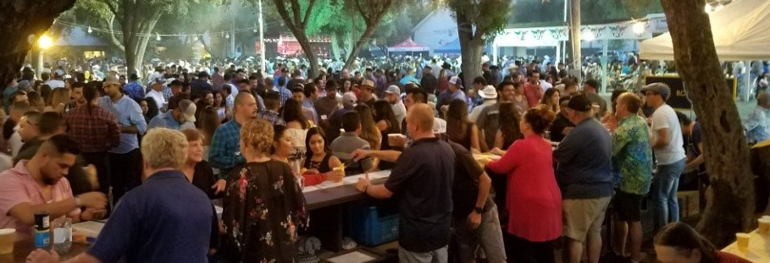

Agenda for Committee meeting 5:30 Monday, 28 March 2022
At Steve’s Pizza, 314 F Street, Davis

- Greetings, introductions, and ‘thank you for supporting the Rotary Beer Booth’ operation.
- Please review the contact list, correct any errors, and initial that you are here.
- The fair announced mid-March they are going ahead a ‘normal’ fair and asked if we wanted to be ‘an active participant’. I said yes. I am assuming we plan for it, recognizing the covid situation may dictate last minute changes. Everyone is in same situation. Thoughts?
- What’s new:
  - Beer booths open at 4pm on Wed, then noon the rest of the fair. Anticipating a Gala Wed evening in the repurposed floral building.
  - Only one stage this year, but it is the Rotary picnic area (us).
  - Margarita bar (Fair Foundation) somewhere in our general area.
  - We have ~$4,600 in the bank from 2019 (primarily to purchase wine up front and seeding tills).
  - Al Aldrete and Joe Muller both no longer in Rotary. Joes avail for consultation. Do we have a place to store all the beer both trappings stored at his house?
  - ABC training: mandatory minimum of one trained shift supervisor at all times. Should have backup. Would be nice if all of us get certified (~45 min on-line course/exam, good for 3 yrs)
  - And fyi, we do have a “Beer Booth Operating Guidelines and Procedures” document that club presidents approved in 2015, and a “Procedures Manual” which provide some structure for us.
  - Need some repairs on the ticket booth (attempted breakin).
- What went well; what warrants review on what we have done in the past?
- What key positions need to be staffed? In past we have had:
  - Do you want a new committee chair? If you keep me, I need a co-chair that will commit to taking over next year.
  - Co-chairs/main coordination team. Maybe rep from Davis, Woodland, Sac/Clarksburg clubs?
  - Wine and beer guru’s (proposing selections and quantities and overseeing beverage purchases with the distributor).
  - Shift managers (two per day), with three shifts of Rotarians behind the bar/day
  - Keg Tappers to keep the suds flowing, including record keeping to aid restocking.
  - Person(s) responsible for daily set up and take down.
  - Money manager during the fair, ensuring reasonable accountability and safe keeping of tickets and depositing of money. Correlate tickets sold with cash from sales by shift.
  - Music selection/coordination with fair??
  - Treasurer-Vicki Faye has agreed to continue in this function.
- Next meeting (what time/place/day of week works best?

