Rotary Clubs of Yolo County Beer Booth Committee-2022 County Fair
http://www.woodlandrotary.org/BeerBooth.cfm (information repository)

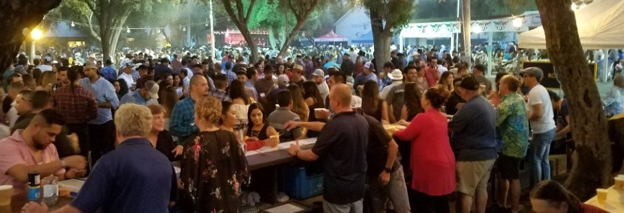

Agenda for Committee meeting
5:30 Monday, 9 May 2022 at Rotary Park, County Fairgrounds
Park at fair office, come in through ped gate

- Greetings, introductions, pizza and water provided.
- Fair updates:
  - Hours: ticket booth and bar open at 6 pm Wed, 4 pm on Thurs/Fri, and noon Sat/Sun. Ticket booth closes at 11:00 pm and serving stops at 11:30 pm each night of fair.
  - Stage has been relocated to the knoll by the East St gate; that is where the only entertainment will be (no stage/music by the arena). No news yet on hours for the music.
- Co-Chairs from different areas: Shaun Morrow , Gretchen Peralta, Susan Lindquist.) Others interested? Sounding board for issues. More in depth review of policies, job descriptions.
- General discussion/identify issues:
  - ABC Responsible Beverage Service (RBS) training and exam
  - Rough draft of job descriptions; thoughts?
  - Slot allocation process/Organization and staffing
  - Ticket booth operation
  - Courier process
  - Music Does anyone want to tackle this?
  - Credentials and passes.
  - Can we use Google Docs, or website? for document storage and collaboration?
    - Procedure Manual 2022.docx
    - Beer Booth job descriptions.docx
    - 2022 Master spreadsheet.xlsx (slot assignments)
    - Beer booth guidelines multi position/2015-10-04 Rotary Beer Booth Bylaws 4Oct15 (Bylaws approved by Mag7+3 club presidents).
- Next meeting Date/Time/Location

