Rotary Clubs of Yolo County Beer Booth Committee-2022 County Fair
http://www.woodlandrotary.org/BeerBooth.cfm (information repository)

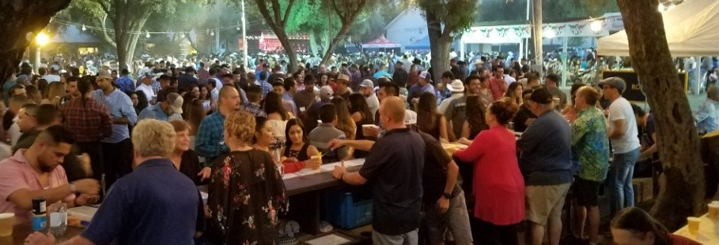

Agenda for Committee meeting
5:30 Monday 6 June 2022
Steve’s Pizza, 314 F St, Davis
- Greetings, introductions.
- Summary of May 9th mtg
  - Hours clarified: open 6 Wed; 4 Thu/Fri; noon Sat/Sun. Wed-Sun sales stop 11; stop serving 11:30
  - Dispenser truck abuts south edge of pavers, facing north. Ticket booth at NE corner of pavers, facing SW
  - Entertainment hours look like starting 6 Wed, 4 Thurs to Sunday, stopping each night of fair at 11pm. Schedule out mid June per 5/25 email fm Sara Bailey, fair office.
  - ABC training (Responsible Beverage Service); required to have minimum 1 certified person responsible on each shift; desire is to have all Beer Booth committee reps certified.
  - Functional responsibilities
    - Shaun: Beer selection, order, training of keg tappers on standby each day.
    - Gretchen: slot allocation, club shift assignments, signups, mgmt during fair. Allocation of credentials and parking passes.
    - Susan: ticket booth operations and related job descriptions, courier operation (need understudy; she will be gone during fair)
    - Ken Wilson. Wine selection, purchase. Point of contact on music issues Sunday.
- Announcements, general issues
  - The fair confirmed the Credentials will give us restricted access through the ped gate north of beer booth. We get 50 total and they are good for duration of fair. (W/o the credentials, we would enter through the main gate and experience any related backup area.)
  - Passes are single use, free vehicle parking pass. They are collected as you enter parking area.
  - Credentials and passes (think slot assignments will dictate).
  - Covid discussion/mask issues.
  - ABC Responsible Beverage Service (RBS) training and exam. Link for RBS LEAD does not satisfy RBS. Again, goal is to have committee mbrs get RBS certified.
  - Job descriptions review.
  - Functional responsibilities (see above; any significant things left out??)
    - Shaun: beer update and discussion on how to handle kegs. Can Shaun plus one handle it?
    - Gretchen: update on slot assignment process, including org structure for fair.
    - Susan: Ticket booth operation/tracking ticket sales by shift w/oversight by Gretchen during fair?
    - Ken Wilson: wine update
  - Purchase of Ticket Rolls and wrist bands. Any one have source; issue is roll to roll consecutive numbering. (May need to number rolls, so tracking would be roll#-ticket#.)
  - Getting ticket booth ready; damage repair.
  - Tip jars prohibited… why not donation jar for Literacy program (United Way)? Separate bookkeeping is a burden.
  - FYI: should be back to 5% holdback for projects this year (or get waiver frm Presidents group)
  - Bookmark website for material. See 2022 Beer Booth (internal) at http://www.woodlandrotary.org/BeerBooth.cfm
    - Procedure Manual 2022.docx
    - Beer Booth job descriptions.docx
    - 2022 Master spreadsheet.xlsx (slot assignments)
    - Beer booth guidelines multi position/2015-10-04 Rotary Beer Booth Bylaws 4Oct15 (Bylaws approved by Mag7+3 club presidents).
- Next meeting Date/Time/Location
  - Need slot assignments to clubs, so they can start filling their slots
  - Need procedures for ticket booth captured in job description. Recording ticket numbers at end of each shift.
  - Need courier slot filled (one person for whole fair?) and procedures written out/in job description.
  - Need Keg tapping process and record keeping captured in job description.

