Rotary Clubs of Yolo County Beer Booth Committee-2022 County Fair
http://www.woodlandrotary.org/BeerBooth.cfm (information repository)
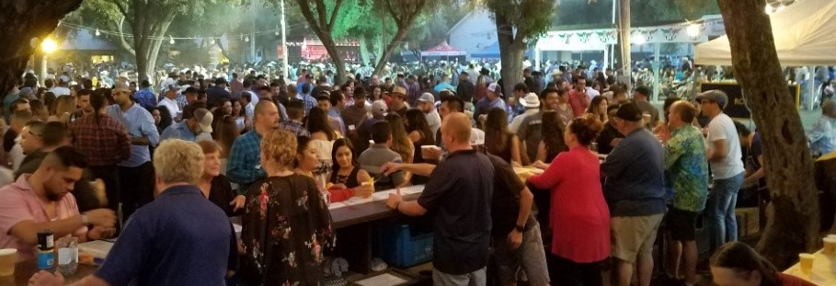

Agenda for Committee meeting
5:30 Tues, 8 August, 2022 Steve’s Pizza, 314 F St, Davis
    - Greetings, introductions. Make sure you sign in. Should the highlighted lines be deleted?
    - Carried forward from previous meeting(s): How is the ABC Responsible Beverage Service (RBS) training going? Go to ABC.CA.Gov and you will see a link to the RBS Portal. And I sent a parsed down list of training programs 8/3 to you all. As of now, all I need is the Server Certificate Details: Status certified; your ID number and renewal date. If we need the actual certificate, we can get that later.

  - Tips: we keep jars behind/below the counter as a repository for any tips. Courier will collect tips at the end of the kday. We will track separately to facilitate cross checking tickets sold with revenue, but then deposit tips with booth revenues in our one account.
- Announcements, general issues
  - Updates from functional areas:
    - Shaun: update on beer order, trailer setup, and how to handle keg tapping?
      - Coors Light (American style light lager) - 46
      - Dos Equis Lager (Mexican lager) - 15
      - Blue Moon Belgian White (wheat ale) - 21
      - Hop Valley Bubble Stash (West Coast style IPA) - 15
      - New Glory Gummy Worms (New England style hazy pale ale) - 15
      - We will have six taps on the side of a large refrigerator truck trailer that will arrive with our full order meaning we will likely not need to reorder. Coors Light will get two taps.
      - We have also ordered sixty mixed cases of hard seltzer. This is three times what we sold in 2019. However our rep says that hard seltzer sales are up 3-4 times 2019 numbers.
      - We have to provide the CO2 cylinders this year. We are picking up 6 20 pound cylinders Wed morning the 17th; should need just 5 if we sold all the beer. All the fittings to hook up are provided by the beer distributer.
    - Gretchen: Wrapup of slot assignment process: are we all in/all done? (Sorry about the mixup on the date for the after fair tear down. (Think there are some slots not filled; can other clubs pickup the slack?)
    - Susan: Ticket booth operation/tracking ticket sales by shift. See attached.
    - Ken Wilson: wine update (just need brand/qty/est price).
    - Administrative (Gary):
      - Tickets on order, wrist bands have arrived. Everyone needs to be age verified and banded to buy/get alcohol. (Discuss ‘age verified’). We are all at liberty to recheck ID for age verification at any time; if you have concerns, don’t be shy.
      - Credentials: multiple entry through the “VIP” pedestrian entrance-(the ped gate by Rotary Park/Beer Booth) We will have 50. I recommend one for each of the committee members and the rest (~to be held at the ticket booth for issuing as needed.
      - Parking pass (single entry, collected as you drive in). I think there are 50 of these and propose 10 for Shaun, Gretchen, Dan Stroski and myself, leaving 10 to be held in the ticket booth.
  - New Items:
    - Woodland Rotarian Dan Stroski will handle courier duties. He is retired from the DA’s office, is a private detective, and has a CCW. Cash handling procedures have been developed and reviewed by him, myself, and Vicki Fay (Treaurer). The courier is responsible for all cash management.
    - Ticket booth and bar sections and Rotary benches are scheduled to be moved into place 12 August. The fair maintenance crew will pressure wash the pavers. They will also provide portable light plants if they determine a need during the fair. Beer trailer coming out Wednesday and Joe will be out to assist in setup.
    - ABC permit and health dept pemit handled by Dick Hoppin. Tab Randolph from Wdld Rotary is handling the insurance coverage (RI)
    - Hand sanitizer; believe we should provide some. Where and how many?
    - Who does What… see attached. Discussion.
      - Keg log, wine log, seltzer log. Daily report to fair. Break even considerations.
      - Ticket booth/ recording ticket sales by shift/window.
      - Shift supervisors

- Next meeting Date (5th or 12th of Sept??) 5:30pm Steve’s Pizza:
  - final wrapup;
  - financial report/money to clubs;
  - suggestions to consider next year

