WOODLAND COMMUNITY COLLEGE – COMMUNITY ELECTRONIC MARQUEE
Excerpts of correspondence with Woodland Community College President Michael White:

- Woodland Community College/Community Electronic Marquee Project:
Just a few hours after meeting President Brooker, I had a fortuitous conversation with our District Chancellor. It appears that the District Foundation (http://yc.yccd.edu/about/foundation.aspx) will match donor dollars for a College Marquee. Rotary will have naming rights to the marquee. In short, your $30,000 gift may be leveraged for a $60,000 (much larger and increased messaging capability) project! Given that we have a Community Room, I can see many opportunities for groups such as yours to use the room and announce to the public on the marquee. I highly recommend your consideration for this project. See image below as an example only of what the marquee may look like.
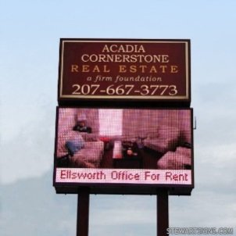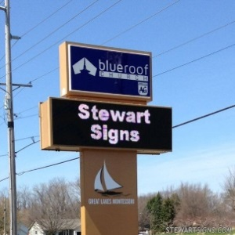

Hi Clyde - I'm very excited with the prospect of this actually happening for our community! Attached you will find two mock-ups of by the vendor (i.e. Mock-up1 and Mockup2). These are merely conceptual, but may give you an idea of our vision. We will have to include some Rotary recognition once approved by your Board. Perhaps on the space between the Woodland College label and the LED screen or in the header?

I have spoken to our Maintenance and Operations staff and they estimate costs to include pulling electricity out to Gibson, pouring the footing, etc. to install. The timing is dependent upon architect plans for installation and height. Under 8 feet (probably the way we would go) would not require DSA approval from the state, but the taller version would indeed need state approval.

The vendor's expectation was from be 3 months (shorter version) to 7 months (requiring DSA approval). In either case, we could have something up and running before the fall semester!

Dr. Michael A. White
President
Woodland Community College
2300 E. Gibson Road
Woodland, CA 95776
mwhite@yccd.edu
(530) 661-5710

