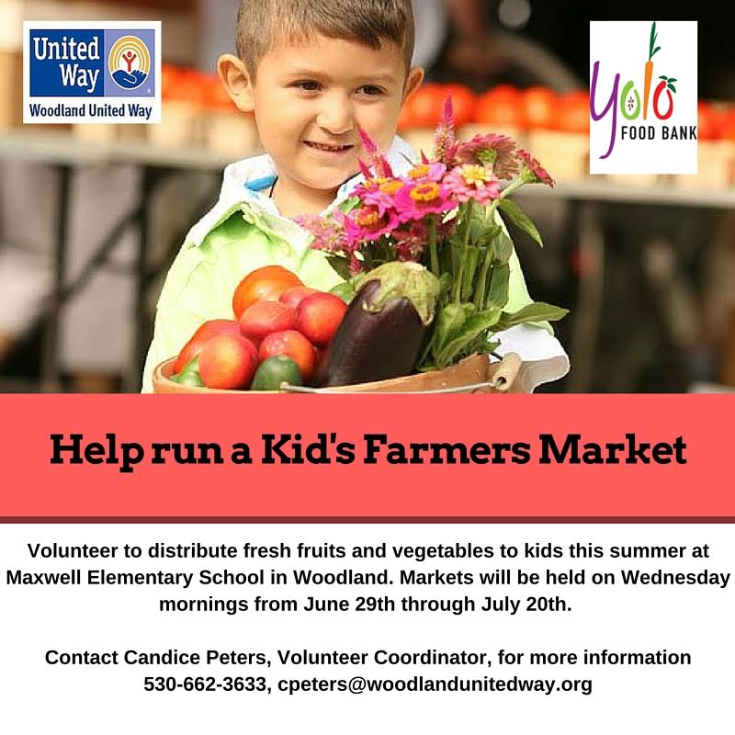

On Wed, Jun 22, 2016, from Candice Peters, Wdld United Way
Hi Gary, Here’s my little announcement about Kid’s Farmers Market. I’m looking for volunteers on June 29th, July 6th and July 20th from 9am to noon. Volunteers will be helping in a number of ways to run the Kid’s Farmers Market: unloading the produce from the delivery truck, setting up the market before the kids arrive, serving as “vendors” (handing out produce and collecting play money from the kids), telling the kids fun facts about nutrition and healthy eating, and then tearing the market down at the end of the day.
If you have anyone interested, they can contact me! A good number of volunteers for each market is about 6-7. Thanks!! Respectfully, Candice Peters
I will solicit interest for two slots each of the 3 days, from Woodland Noon Rotary.
Gary Wegener

 | 29 June-9 to noon | 6 July-9 to noon | 20 July-9 to noon
Woodland Noon Rotary?
Woodland Noon Rotary?
??
??
??
??
PS The Farmers’ Market is being run in conjunction with United Way’s pilot KinderCamp at Maxwell School, providing a quality preschool program for incoming first graders. United Way has targeted early childhood literacy as a key focus area, and there are two components of that effort. If you are interested and can spare 3 hours one of these days, call Candice. The slots aren’t reserved for any one or any club in particular; first come, first served. Gary

