DRAFT
Rotary Yolo County Beer Booth Procedural Manual

Signs (will beer distributor make them):
(note: fair stays open till midnight on Sunday, and Sara/Carolyn say we can stop ticket sales at 11 and stop serving at 11:30 if we desire. Might be good way to finish kegs.)
Key Phone Numbers
Beer Booth Chair/contact for security issues: Gary Wegener 530 908 4914 cell
Lead Beer Master/Keg Tapper: Joe Muller ___________ 530 309 8580 cell
Club Committee Representatives:
List one(?) per club

Security/CHP cell phone ___________
Ice Man (for drop offs)
Fair Maintenance:
Smart Foodservice® Store #560 - Sacramento, CA
1101 RICHARDS BLVD
SACRAMENTO, CA 95814
(916) 441-1618
Mon-Sat 6a-6p; Sun 8a-5p
Fair office (for access to vault) office #______________; cell # ___________
Holy Rosary (or Our Lady of Guadalupe?) Taco Booth
Hours, menu prices. (contact is Juanita Mendoza 908 8859)

Beer Booth is serving:
Wednesday 6 to 11pm (ticket sales stop 10:30pm)
Thursday noon to 11pm (ticket sales stop 10:30pm)
Friday noon to 11pm (ticket sale stop 10:30pm)
Saturday noon to 11pm (ticket sales stop 10:30pm)
Sunday noon to 11(12?)pm (ticket sales stop ½ hr before closing)
$5.00 tickets (red) Coors Light
$6.00 tickets (green) Premium (all other) beer, wine, hard seltzer.
(Food Booth Identification-health code reqmt)
Rotary Beer Booth
Rotary Clubs of Yolo County
Woodland, CA 95776
530 908 4914
(leave 8 ½ x 11 room for health permit)
Also need to post pgs 12, 13-self inspection checklists (see pg 3 of county rqmts)

BBC Responsibilities
- Brewmeister: Shaun Morrow-W. Sac
  - Comparison with prior year and selection, ordering (brand/number of kegs) for this yr
  - Coordination/scheduling trailer(s) and deliveries.
  - Returns after the fair, final invoice
- Wine guru (Ken Wilson)
  - Selection
  - Ordering (estimate 24 cases, 2 reds (10cases) and 2 white (14 cases)
  - Storage

- Al Aldrete-Wdld Sunrise: ________?____________
  - ABC permit with attendant paperwork
  - Cash management and daily record beginning/ending ticket numbers on each roll.
  - Daily keg and wine bottle count (open containers) and nightly report to Fair office
- Jeff Kowes Davis noon:
  - entertainment liaison with Marty. (see Dean’s concerns, attached)
- Joe Muller-Wdld Luna Vista: _______?_____________
  - lead person for the beer booth setup before, and take down after the fair. Needs a team of 2?
  - daily, insure proper setup/supplies, limes/oranges/towels for each day, and close up/lockup at night.
  - will oversee the keg tapping operation, logging when/what kegs are tapped, training others to assist
  - Need to figure out how to handle storage of booth ‘stuff’ at Mullers farm.

- Gretchen Peralta-Davis Sunrise
  - Slot management: insure they are filled out, turned in, posted, and participation is recorded.
  - Scheduling slots for fair. Attendance tracking??
- “Day Supervisors” present/available for each day of the fair (may need to train folks).

- Need “Shift Leads” person present whole time for each shift.
- Secretary (minutes, membership list, ….)?? 2nd set of eyes …
- Checking account: Vicki Faye, is the Beer Booth Treasurer. Lynn Jepsen is the Wdld Sunrise Rotary Treasurer. We have a checking account with First Northern Bank (established under the Tax ID number for Woodland Sunrise Rotary) with Vicki and the Beer Booth Chair having signature authority for the account. IRS tax filings are covered by Woodland Sunrise Rotary’s filings. (Sales tax issues are handled by the Beer Booth Chair).
  - Vicki can be the Rotary eyes on counting/depositing the money mornings after the fair (she is a manager at the local First Northern Bank where we deposit our proceeds).
  - The Rotary Beer Booth account checkbook and all current and prior documentation is held by the Beer Booth Committee (BBC) Treasurer. The BBC Treasurer will reconcile the bank statements. The Woodland Sunrise Rotary Treasurer has view only on-line banking access to the Beer Booth checking account but cannot sign checks. Any expenditures should be pre-approved by the BBC Chair and related reimbursement requests must have a receipt or an invoice and be forwarded to the BBC Treasurer, via the BBC Chair. When bank statements are received the BBC Treasurer will forward it to the club Treasurer with invoices and receipts for reconciling (or does the BB Treasurer do this?? Discuss with Lynn and Vicki). After the event both the BBC Treasurer and Chair will reconcile the beer booth proceeds and distribute club shares to the clubs.
- Gary Holman??-prep the ticket booth, change out AC?

Committee responsibilities
- The fair will send the BB Chair a notice of intent to continue the beer both usually at least 60 days before the fair. This needs to be signed and returned to them along with a check for electrical charges ($125)
- At least 60 days before the fair order the beer tickets from the fair. They will place the order and bill us for them
  - We had approximately 3 rolls (2000 tickets per roll) of the pink ($5) and the same of the green ($6) left after 2018. We ordered 6 rolls of each color for 2019. Best to have more than needed because we never want to run out.
- At least 30 days before the fair
  - Request a letter from the fair authorizing Rotary to sell beer (and wine/hard seltzer?) at the fair
  - Al Aldrete to take this letter along with an ABC temporary beer permit request to the Yolo County Sheriff (and CHP???) office to have them sign off on our request
  - Take the completed forms to the ABC office on Del Paso Blvd in Sacramento (I prefer to take these in so there is no question about their being received) We apply for a beer and wine permit, cost $50 day so $250 for the permit application. The ABC will then issue a permit which can be picked up after they notify us. I prefer this was instead of mailing.
- Insurance requirements
  - We are required to have a certificate of insurance issued and a copy sent to the fair
  - Gary W Request a copy of a contract from the fair to operate the beer booth (don’t believe this was required in 2019), and
  - Email the contract to the Rotary International insurance contact along with the special wording for additional insured (40th District Agricultural Association) that is required by the Fair (Tabb handled, didn’t need the ‘contract’; got separate Certificates of Insurance for each club).
- Gary W: Apply for a Health Department Permit to operate the booth, and a not for profit fee exemption application. Click here for forms. We are a 501 c 4 (verify), so if we apply for the exemption, we are not be required to pay any fees. (Go to County office at Ashley and Beamer. Explained the multi-club situation; they were ok with Woodland Rotary as the “owner/business” and they looked up our EIN on file.) The main issues with the health department are:
    - No processing of product outside of an appropriate kitchen
We cannot cut up the limes and oranges in the booth, we can have someone do this at home and bring prepared product in zip locks
    - There must be a hand washing station (rent one) at the booth
      - Warm water in a jug, soap, towels and a waste bucket under the spigot
    - Side note, the towels need to be washed every evening if possible, if not they can mold and become unusable
- Approximately 45 days before the fair, review the schedule from last year and make any adjustments as needed from past experiences
  - Since some clubs have more members and different demographics. Check schedule and adjust as appropriate.
  - Send the schedule out to the club contacts for listing the signup for assigned slots.
- Joe Muller has been the lead for setting up the beer booth area the Sunday before the fair.
  - He stores the booth equipment at his farm in a Rotary Container
  - He also orders the limes, oranges, water etc
- Gary Holman handles the portable light unit needed and coordinates the preparation of the ticket booth, and placement, and return to storage, after the event.
- Ronnie Gedatus is my contact for Bogle wine each year
  - She can help with quantities
  - We have many requests for a sweet wine which they don’t carry
- Burgermeister: Shawn Morrow West Sac.
  - The 2022 beer distributer is Golden Brands Reyes in West Sacramento. Contact: Will Saenz, cell 530 220 9899, office 916 373 5789, emakil wsaenz@reyesholdings.com (let Carolyn at fair office know if any problems with them.)
  - Pick the beers/micro brews in addition to Coors/Coors Light (required??).
  - Sara/Bart said hard seltzer is ok, has to be by the keg from DBI, and fair cut is $200/keg (same as beer). They are ok with $6 ticket. (need to verify)
  - He will need a copy of the ABC permit to process our order
  - Beer cups and wine cups (verify)
    - Per Carolyn/Sara, the beer cups should be 14 oz, for a 12 oz pour. Wine can be a 7 oz ‘cup’ and a lessor pour (our call). GW
    - Restaurant supply had the best price on cups 14 oz but we need to order in advance as we use about 20,000.
    - Wine glasses need to be 7 oz. Found these at Smart and Final
- Credentials and passes:
  - Fair will provide a pass for the money courier (does this mean free parking and credential pass privileges) , and a place to park outside the gate but as close as possible to the beer booth.
  - Each booth will receive 50 credentials that will allow servers to go through the credential lines in designated areas so they don’t have to wait in the main entrance lines.
  - One day parking passes; each booth will receive 50 one day parking passes (clarify if this means one vehicle entry into the fair parking area, then pass surrendered).
- The beer booth needs to be set up ready to go about 30 min before fair time
  - Wed 5:30 pm for a 6 pm opening
  - Thursday-Friday 5:50 pm for a 6 pm opening
  - Saturday-Sunday 11:30 am for a noon opening
  - The opening tills and tickets need to be set up at this time
- Closing time for ticket sales is 11 pm and beer sales end at 11:30 pm
  - Final pickup of money needs to be collected at this time
  - Through out the fair there needs to be periodic pickups as money collects in the ticket booth. Need to mount a locked cash box.
- Procedures for handling money and fair reports
  - Two weeks before the fair starts we will need to order start up till from Vicki. (Note: for each day of fair, we deposit all the money (proceeds mixed with startup money) and the next day join in counting at the bank and withdraw the startup money for the day.
    - For Wednesday: $500 in $1, $500 in $5 and $500 in $10
    - For Friday $1500 in $1 and $500 in $5
    - Adjust change total as needed
  - Each evening (or no later than the next am) we need to file a report with the fair office of number of “kegs tapped” and wine bottles opened. Figure out how the canned seltzer drinks are handled. Scan and email the report each evening (_______)
  - For every keg tapped, we are charged $200
  - At 11 pm each day, pull all the funds, bag it in the night deposit bank bags, mark date and time and with money handler’s name and courier’s name and put in in the fair office vault (or night drop at First Northern). Discussion item: why hand count the money when the bank will use their counting machines (believe they have two so they cross check) and credit our account using their numbers. (We generally undercounted almost every hand counted bag in 2019, over $5k in total.)
  - EIN and bank account number:
    - EIN 363980900
    - First Northern Bank Account Number: 202-641024
    - Debit card: 5581 0800 8009 2818

- The Day Supervisor needs to be present, especially at shift change, that is when policies seem to change.
  - Policies that should not change
    - Red tickets are $5, green tickets are $6
    - We do not need to wristband everyone only those that look like there is a question as to age
    - Counterfeit checking devices should be used for all suspicious bills, and $50’s, $100’s (maximum we accept).
    - Stress that we only take Rotary Beer tickets at our booth (we can easily end up several hundred dollars short, with the incorrect tickets.)
    - No alcohol consumption is allowed during a shift.
      - This seems to come up every year, the booth manager has to enforce this, as it has the potential to affect our permit. ABC does random inspections.
  - Change should not be sold to other booths.
- Sunday is always a challenge to determine when to tap the last kegs. Currently each keg tapped costs us $200 for the fair and about $150 to the distributor for the keg. Since each keg (15.5 gal) serves about 124 beers, we need to sell half of it (about 63 beers) to break even.
- Sunday evening it is very helpful to have volunteers in front of the beer booth doing wrist bands and selling $5 tickets (easy change) to keep the lines moving.
- After the fair it is necessary to review the DBI bill and the bill from the fair and issues checks (Vicki, Joe, Gary, Al)
- The Beer booth accounts are a subaccount of the Rotary Club of Woodland Sunrise, for their non-profit status. They will incorporate beer booth operations into their tax filing. (Vicki Faye)
- Important!! January 31st the sales tax report is due. (Gary, Vicki) This can be done online and paid by an EFT payment or mailed in. The current sales tax rate is .0725. Since the Fairgrounds are on state property, sales are not subject to a district tax for the City of Woodland. Sales tax is determined by taking the gross sales figure from beer sales dividing that figure by 1.0725. That will give you the net sales figures after the sales tax has been deducted from the gross. Multiplying that figure by .0725 will give you the sales tax due amount. Adding the net sales and the sales tax should equal the gross sales for the event.
Rotary resale permit number is 100514792 express login is f269462h this may have changed when they upgraded the site?????????

Appendix I Fair correspondence
Hi Al,

I have attached the ABC packets for the temporary alcohol permit.

When applying for the ABC permit, you will be required to have a letter of authorization from both the Fair Office and the Yolo County Sheriff’s Office prior to getting the permit from ABC.

Complete all forms, I will need to sign the application form, I will have the authorization form ready for you when you stop by the office for signature.

Our office is open from 9a.m to 4:00 p.m. closed on Wednesdays, if you have any questions please let me know.

Thank You, Carolyn

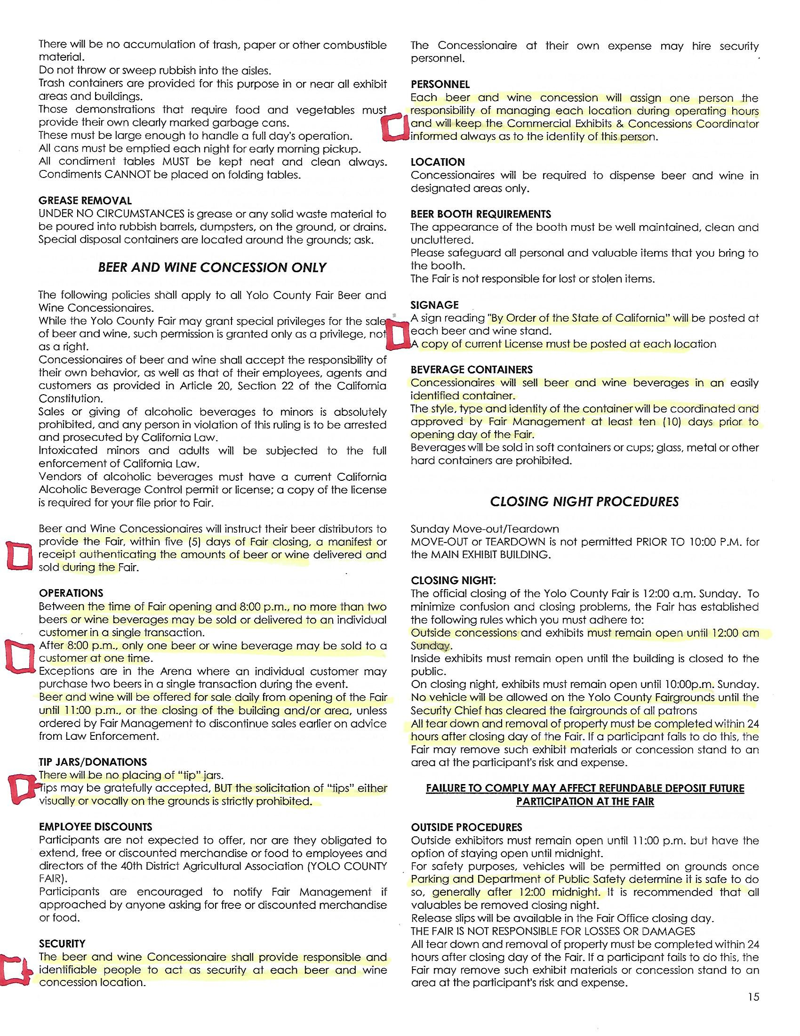
from the Fair Vendor Manual:

