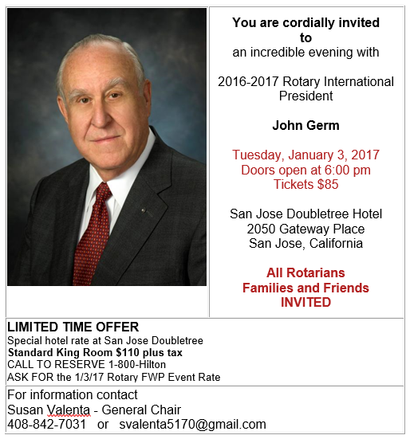
TO REGISTER FOR THE DINNER USE THE LINK SENT IN NOV 29, 2016 EMAIL
TO ALL DISTRICT 5160 ROTARIANS
FROM DISTRICT GOVERNOR FRED COLLIGNON

