Rotary Shirts Available
Call 668 1055 Printers Ink

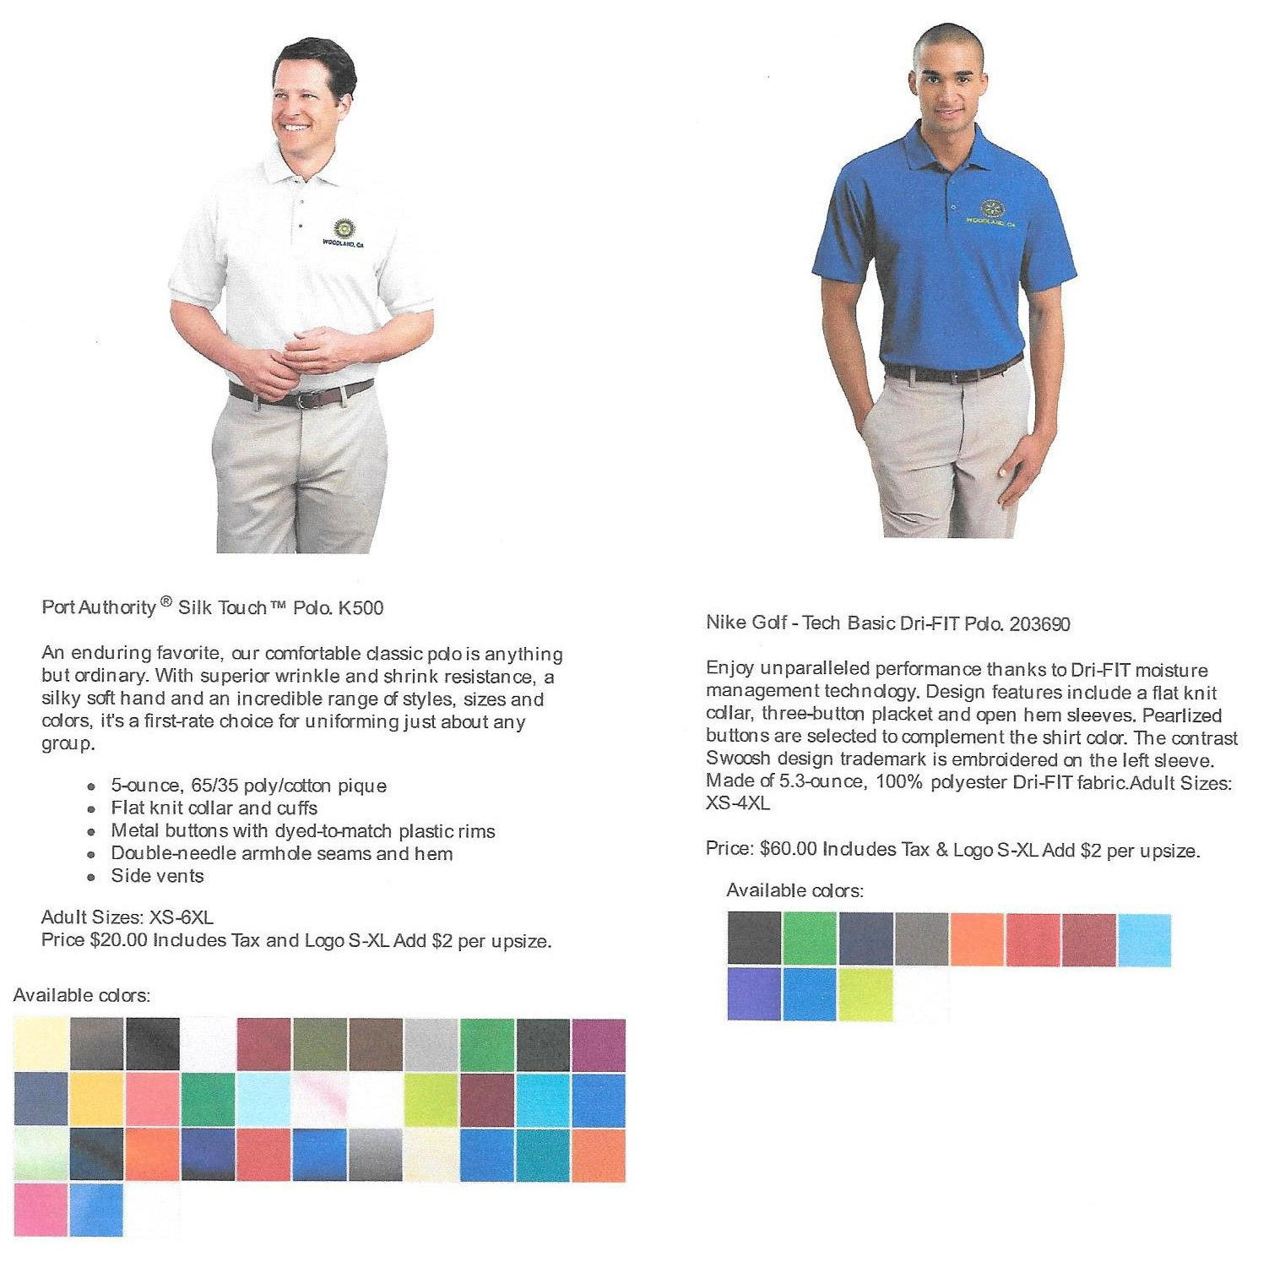
Want a Rotary polo shirt? – Former Rotarian Richard O'Malley and his wife Cathy, have teamed with Printers Ink and are offering polo shirts embroidered with the Woodland Rotary logo. Three options are available:
(1) Port Authority model; 65% polyester & 35% cotton; 35 colors to chose from; $20 each includes tax ($2 extra for upsizes above XL); and
(2) Nike Golf model; 100% polyester; 11 colors to chose from; $60 each includes tax ($2 extra for upsizes above XL).
(3) Customer's shirts can also be embroidered for $10 each (excludes tax).

Contact Printers Ink at 530 668 1055 to place your order.

