Custom Woodland Rotary
T-Shirt Order Form
Mens & Ladies - $19.95

Name:____________________________________________

Quantity:_________ Size:__________ Total:_____________
Mens Sizing:
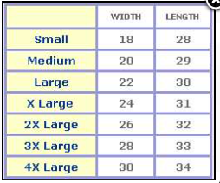
Ladies Sizing:
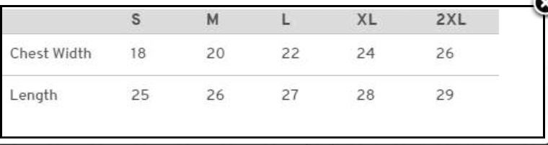

Woodland Rotary – Polo Shirt Order Form
Mens $38.95 (Navy Blue)

Name:____________________________________________

Quantity:_________ Size:__________ Total:_____________

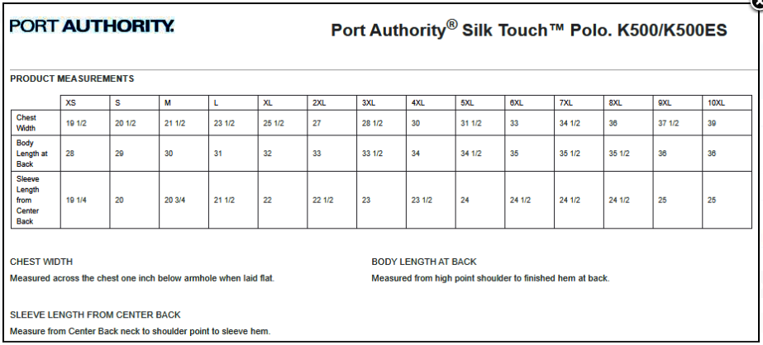

Woodland Rotary – Polo Shirt Order Form
Ladies $38.95 (Navy Blue)

Name:____________________________________________

Quantity:_________ Size:__________ Total:_____________

