Madeline Senter
Outbound to France

September Quarterly Report
Travel
I left California on Monday, August 26. My flight was at 3:20pm, but my sister had a flight to Boston on the same day, so we woke up at four in the morning to drive to the San Francisco airport. After we said goodbye to my sister, I had about five hours before I needed to be going through TSA, so my mom, dad, and I went and got some breakfast in a nearby town, and then hung out at a park and relaxed a bit. Airports make me nervous, so I couldn’t eat much and felt a little bit sick. By the time we returned to the airport however, I felt somewhat better.
I randomly got TSA Pre-Check, so I got through the lines and to my gate in probably about seven minutes. I found another exchange student at my gate from District 5190 and soon after, we boarded. The flight was almost eleven hours long and I didn’t sleep very much on it. When we flew over Paris, I saw the Eiffel Tower! I got through customs and immigration without incident and didn’t have to wait long to board my next flight, going to Toulouse. This flight was only an hour and I managed to rest a bit on it. We landed at TLS, I found my bags in baggage claim, and walked into the main part of the airport.
I was greeted by my host mom, Myriam, my host grandma, Odile, my host brother, Tom, and some club representatives (Jean-Pierre Boutet and Christiane Thenegal). I was tired when I arrived, but very happy. My host family and I then left the airport and drove to Cahors, my host city. It is about an hour and a half away from Toulouse. When we arrived at the house, I was so tired that I slept for four hours! I had been awake (in varying levels of consciousness) for more than 24 hours.
When I woke up, we had dinner outside in the backyard. My host family lives in the countryside, about four miles outside the town and it is so beautiful! I saw the sunset when we had dinner that night!
The next day, my family took me into town and showed me around. In Cahors, there is a middle ages bridge called the Pont Valentré. We walked across it (it was so old and cool and very exciting!!) and then they showed me my school, Lycée Saint-Etienne. We then got some ice cream and walked to the cathedral in town (called la Cathedral Saint-Etienne). It is celebrating its 900th birthday this year! The next day, I went off to a four day language camp.

Rotary
My rotary district is very big; it covers a large part of the southwestern corner of France (all of Occitanie, or the former Midi-Pyrenees and Languedoc-Roussillon regions). There are 23 inbounds and about 25 outbounds (I think). My rotary club, Rotary Club de Cahors, doesn’t have an attendance requirement as far as I know. I went to my first meeting with them on September 5th. It was great getting to meet the club. I’d already briefly met the president and my youth exchange officers/counselors at the inbound orientation/language camp, but it was good to re-learn all the names and faces. My club is hosting another student from Finland named Benjamin. He attends the same school as me, so I’m not always on my own which is great! My club has a fundraiser for guide dogs for the blind in October, which I’m looking forward to participating in! In November my district has a dinner in Toulouse that all the exchange students attend, and in January we have a snow weekend! I’m very excited for both! Also, in March, there will be a conference in Reims for all the exchange students in France (approx. 600!) and I cannot wait!! It only happens every three years, so I feel very lucky! :)

Language Camp / Inbound Orientation
My inbound orientation was four days long and included a ten hour French course. The first two days were language camp and on the second two, we explored a middle ages village and a cave with prehistoric paintings. The language camp took place nearby Cahors, so I didn’t have to wake up early to catch a train or get on a bus like most other students had to. Right off the bat, I made friends with a girl from Finland named Iiris (that’s two “i”s). We had a lot of fun together that weekend!
The language camp started with French basics, like the alphabet and greetings, and then moved on to verbs, adjectives, and nouns. I’ve learned French for the past two years, so the language course was a lot of review for me, but I still think I benefited from it.
The rest of the inbound orientation was very fun! We took a boat down the Lot to a small middle ages village. The village, called Saint-Cirq-Lapopie, had been beautifully restored and walking around it was so cool. I’d never seen anything that old, so it was really amazing to be there. It was gorgeous as well! Saint-Cirq-Lapopie sits on the top of a steep hill right next to the Lot and has beautiful views of the river, forests, and some farmland. After our exploration, we walked back to the town where we got on the boat earlier in the day (about a 2.5 mile walk).
The next day, we’d planned on canoeing, but it looked like it was going to rain, so the rotarians decided to take us to Pech Merle, a series of huge caves with paintings on the walls. It was so amazing to see drawings of people and animals that lived thousands and thousands of years ago. It still amazes me how much history there is here in Europe.

School
At school I have twelve different classes! Woohoo! My schedule changes every day, and I finish school anywhere between 2pm and 6pm. I also have (for two classes) a Week A schedule and a Week B schedule, meaning that every other week, my schedule changes. My classes are:
- French
- French (but this time with seventh graders)
- English
- Math
- History, Geography, Geopolitics, and Political Science
- Humanities, Literature, and Philosophy
- History and Geography (this is a different history and geography than the previously mentioned one)
- Physical Education
- Enseignement Scientifique (made up of three classes that change from week to week: physics/chemistry, biology, and math)
- Art Plastiques (basically a drawing and painting class)
- Music (the second class I have with the younger students)
- Enseignement Morale et Civique (still not entirely sure what this one is)
In addition to my classes, I spend one hour a week in the school library teaching myself French. My school understands that I’m still learning the language, so technically, only my morning classes are mandatory, but I’ve decided to take a full day of courses for two reasons: it makes me feel less like a kindergartener and I will benefit in my understanding of French.
All of my teachers are very nice and I can tell that they enjoy what they teach. I haven’t made many friends yet but there are people in my class who are nice to me and interact with me a bit. I mainly hang out with the other exchange student, Benjamin. I have most of my classes with him and we are at about the same level in French. He also speaks pretty good English, which is great, except that I feel bad that I don’t know Finnish.
My first impression of the school was that all of my classes are inside one big building. That’s so different from California, where I walk across campus to get to my classes. Some other differences are that the school is in the old part of town (very small streets and very tall buildings) and the staircases in the main building are spiral staircases.
In most of my classes, I can understand what is going on based off of what my teachers are writing on the board and anything I manage to hear and understand. I can’t participate and raise my hand yet, but I try to learn, take notes, and pick up what I can. When I can’t understand what is going on, like when we’re analyzing French literature, I take out my dictionary and work on translating any handouts or homework I’ve been given. Right now I feel like I’m learning French, but it’s hard for me to see progress, which is a little frustrating. But I’ve only been here for two weeks, so I’ll give it some time before getting super hung up about it. My listening and reading comprehension has definitely improved since I’ve arrived, and I can form sentences quicker.

Host Family
I’m going to start off by saying that I love my host family! They are so sweet and fun to be with, and I’m very glad that they’re hosting me. My host mom, Myriam, works in insurance and speaks very good English, which is helpful when I forget words. She likes to cook and so far, we’ve made a strawberry pie and a chocolate cake together! My host dad, Franck, works in agriculture business. He travels a lot for his work and was away when I arrived. He is from northern France and speaks a lot faster than most people in the south (where I am), so it’s hard for me to understand him sometimes, which is always really funny. My host brother, Tom, is thirteen years old and loves soccer. He’s a little quiet but is super funny and nice. I’ve always been the youngest person in my family (cousins included) so it’s interesting being the older sibling for once. I have a host sister, Faustine, and she is on exchange in Mount Shasta right now! I have a super sweet host dog as well. His name is Newton and he is two years old! I love him so much! I also have a very kind host grandma named Odile who wrote down a list of sentences in English and has said to me a few times “make yourself at home!”. I’ve also met my host aunt, uncle, cousins, and great-grandma! It’s a very large family!!
My host family knows I enjoy soccer and asked the local club if I could play with them. So far, I have gone to two practices and had a lot of fun. It’s a “seniors” team, so anyone seventeen and up can play with them. I’m sixteen, but I don’t think they have any girls teams for my age group. It’s fine though, everyone on the team is very nice and I’m having a lot of fun! Faustine’s friend Emma is on the team, and she has been so nice and welcoming which makes me very happy!!
I feel like I have a pretty good relationship with my host family. I do my best to help out with chores like setting the table, washing dishes, and doing laundry, and I try to interact and participate as much as I can in the family. It’s hard to participate sometimes because I don’t understand a lot and can’t speak much, but I hope they understand that I really appreciate them and that I am having a lot of fun even when I’m sitting and listening to them interact.
Also something to add: I have a blog that you can follow! I hope to update it often! You can find it at: https://peregrinate.travel.blog :)

Photos!
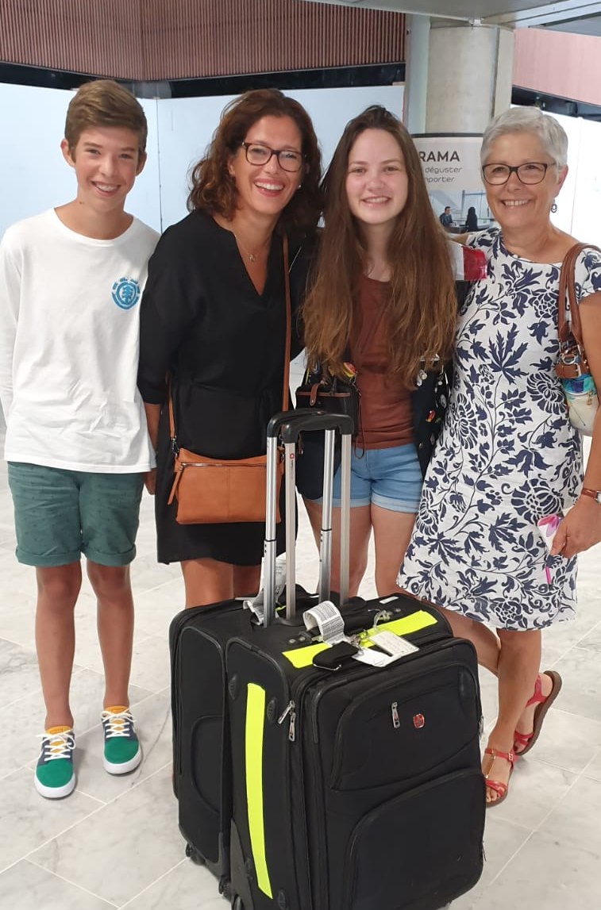
With my host family at the airport! From left to right: Tom, Myriam, me, and Odile.

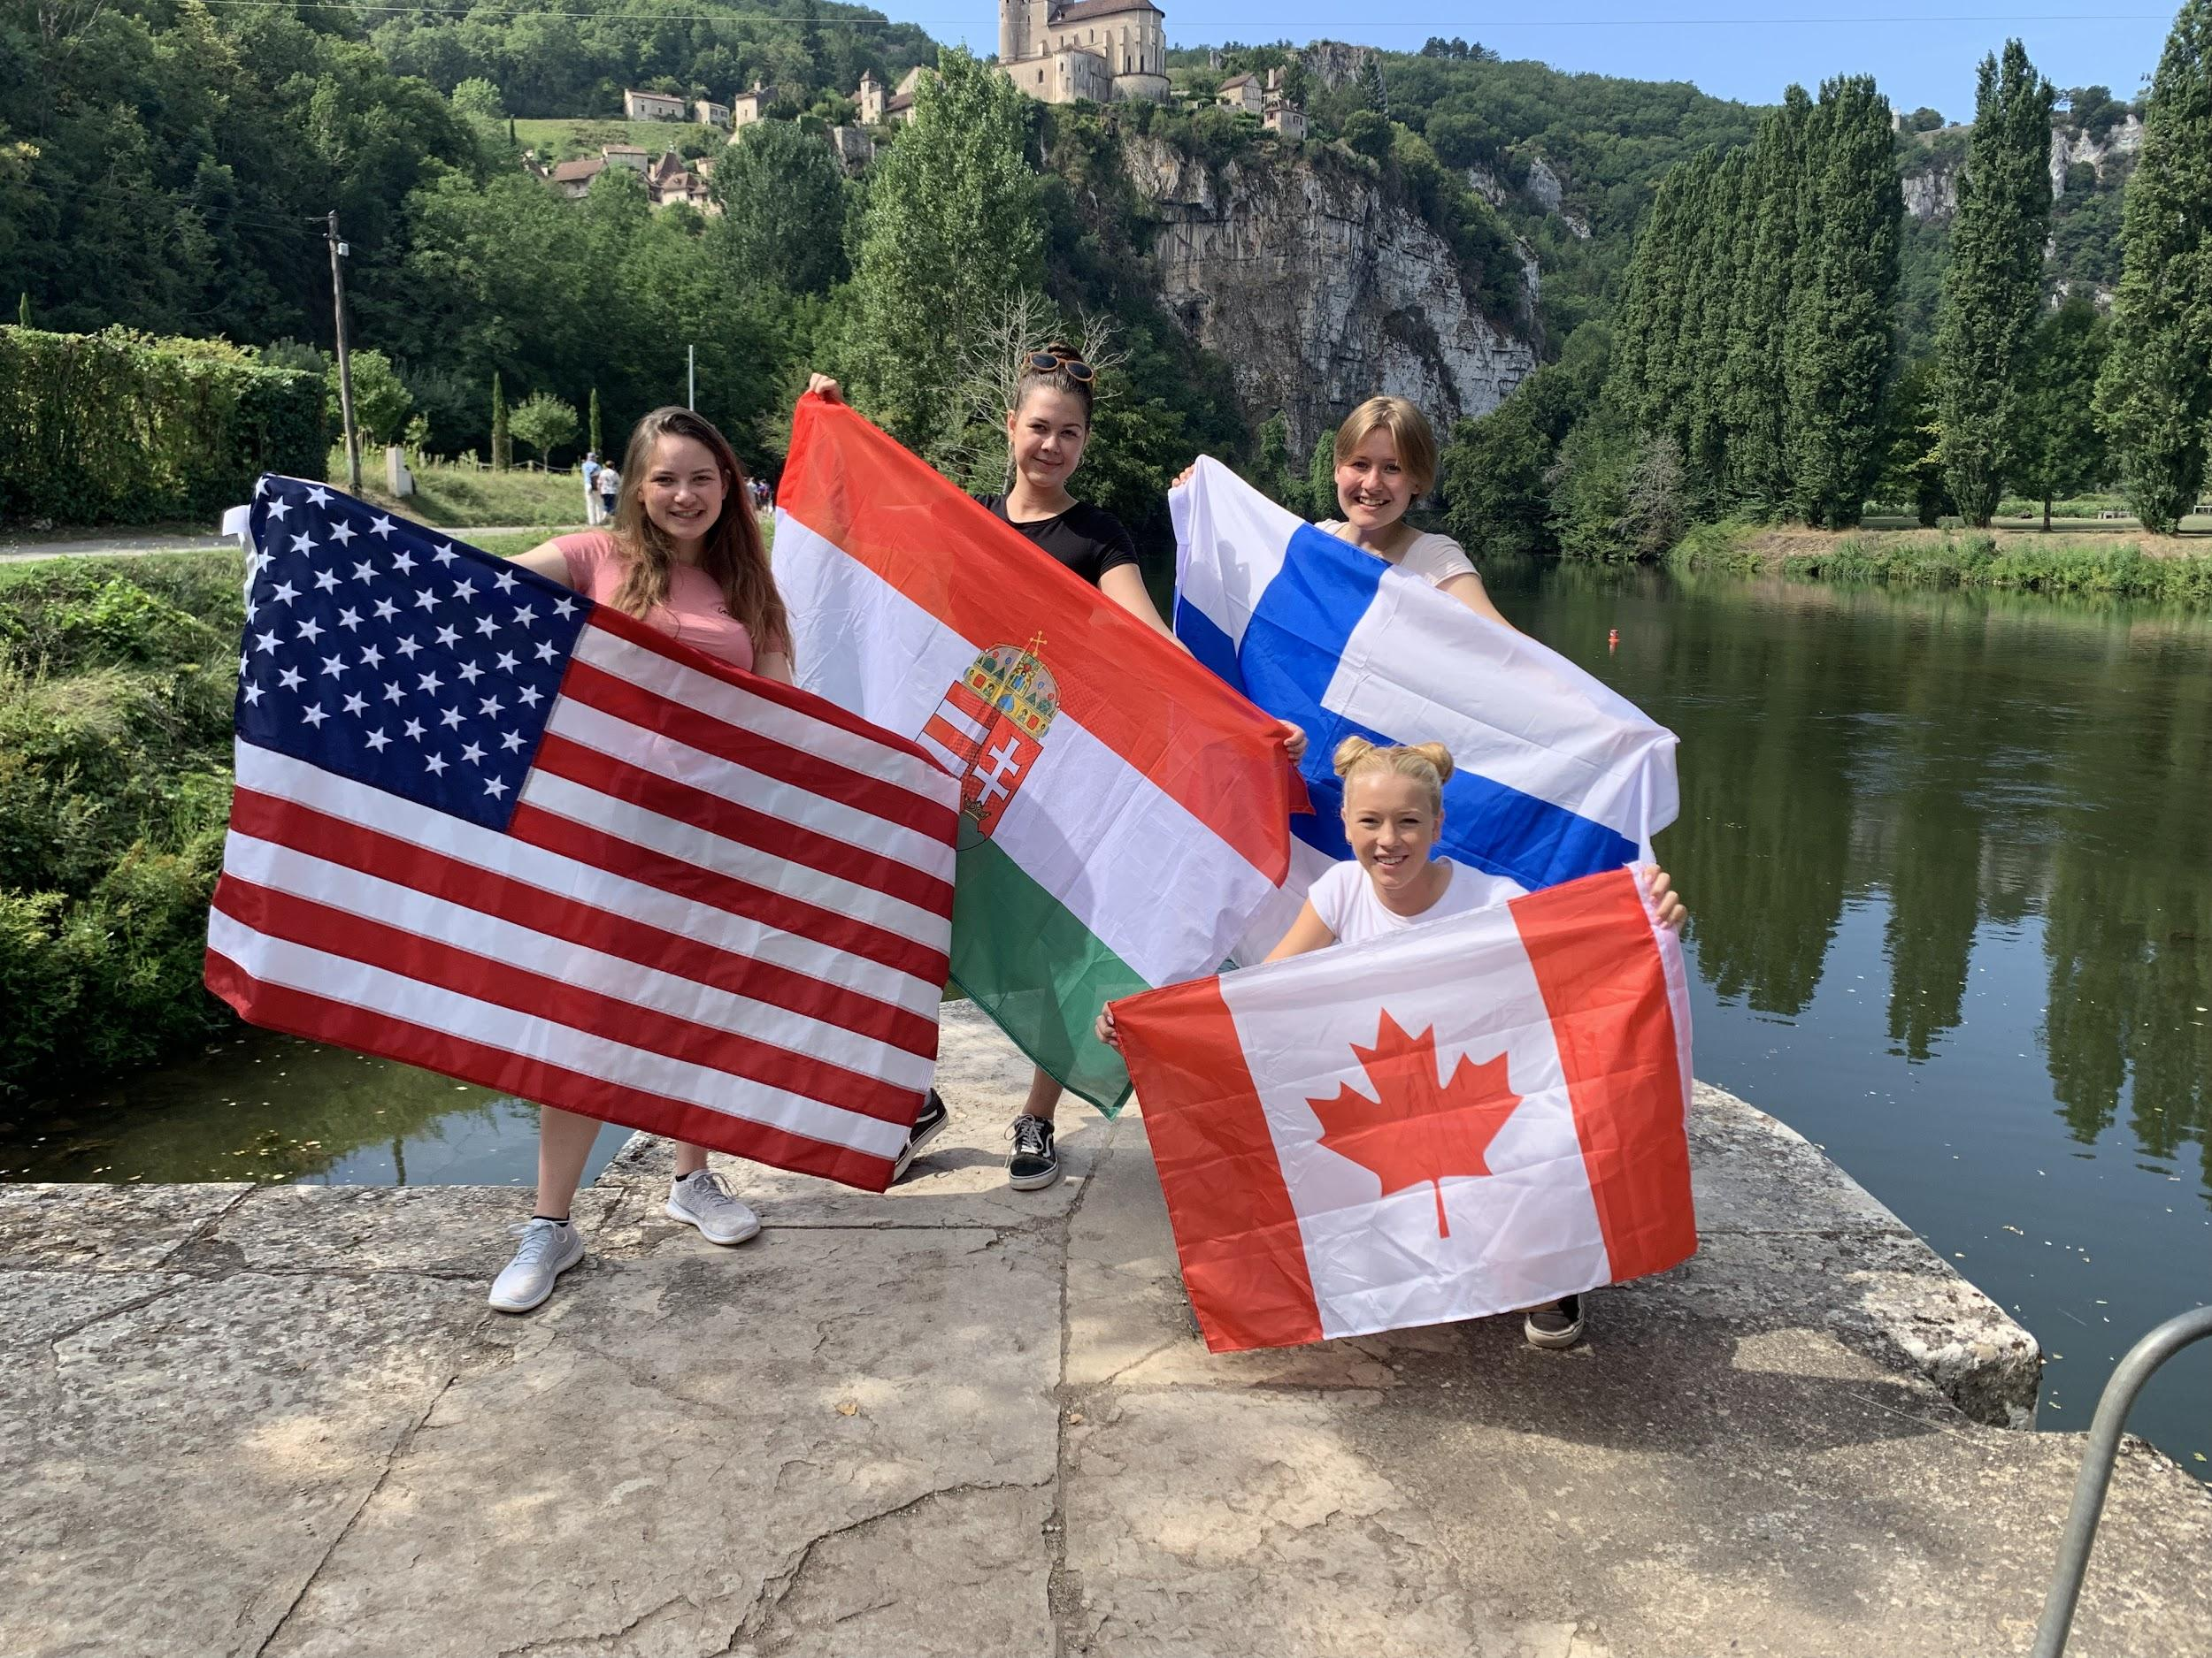
This is me with some of my exchange buddies! In the background is Saint-Cirq-Lapopie. From left to right: me, Jazmin from Hungary, Iiris from Finland, and Marit from Canada.

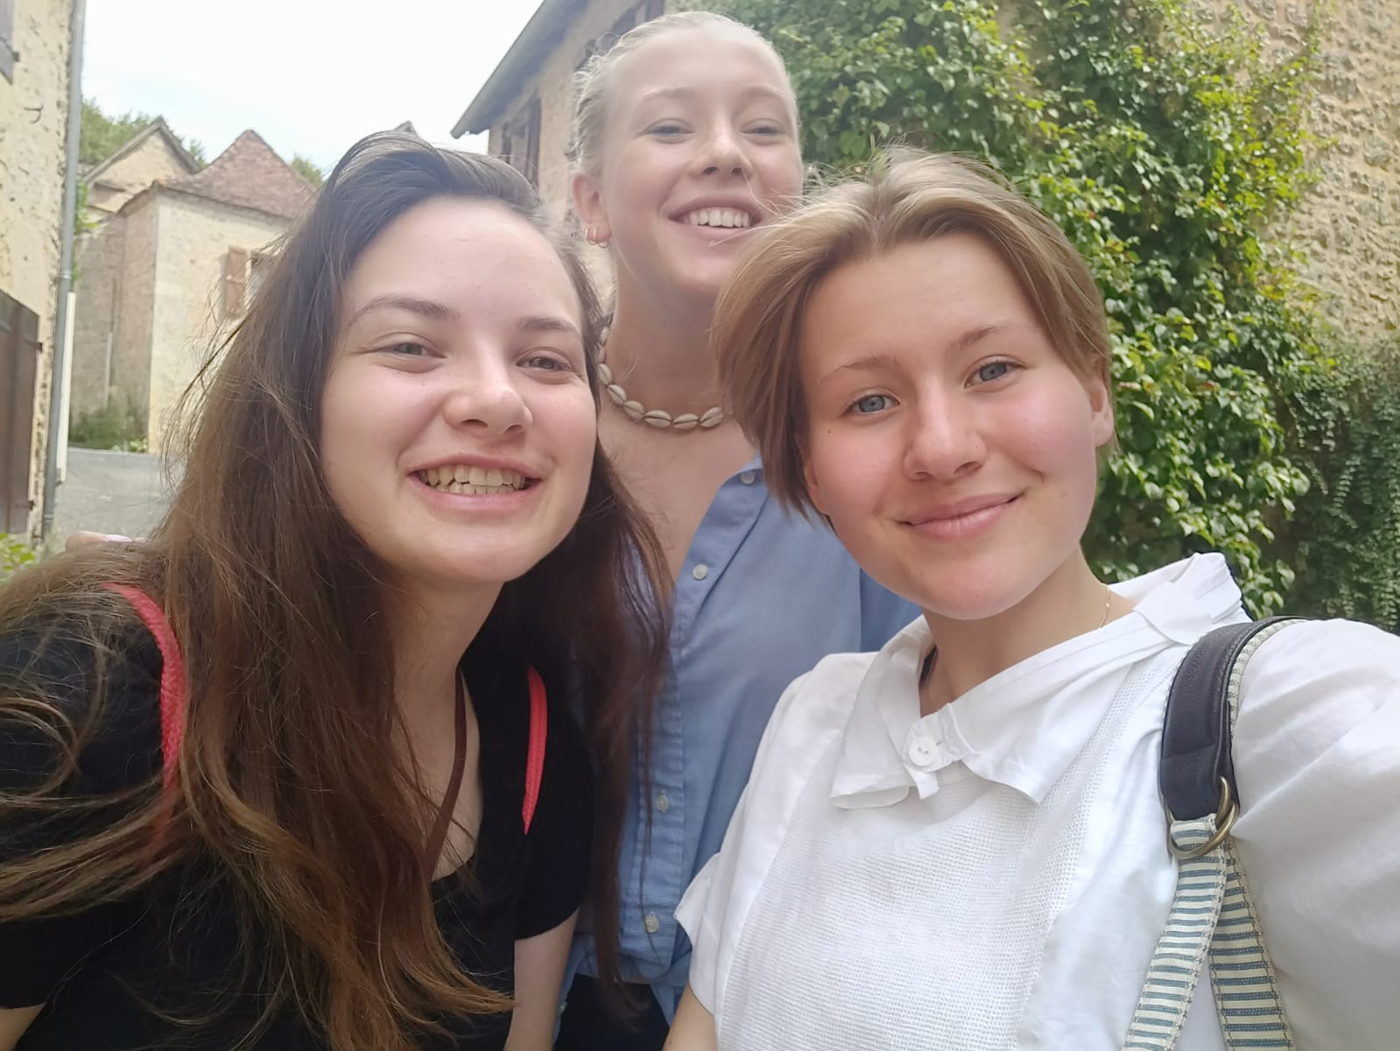
With Marit and Iiris! This is from the same day that we saw the cave paintings. We got to walk around a super tiny village and have lunch there! It was a very fun day!

