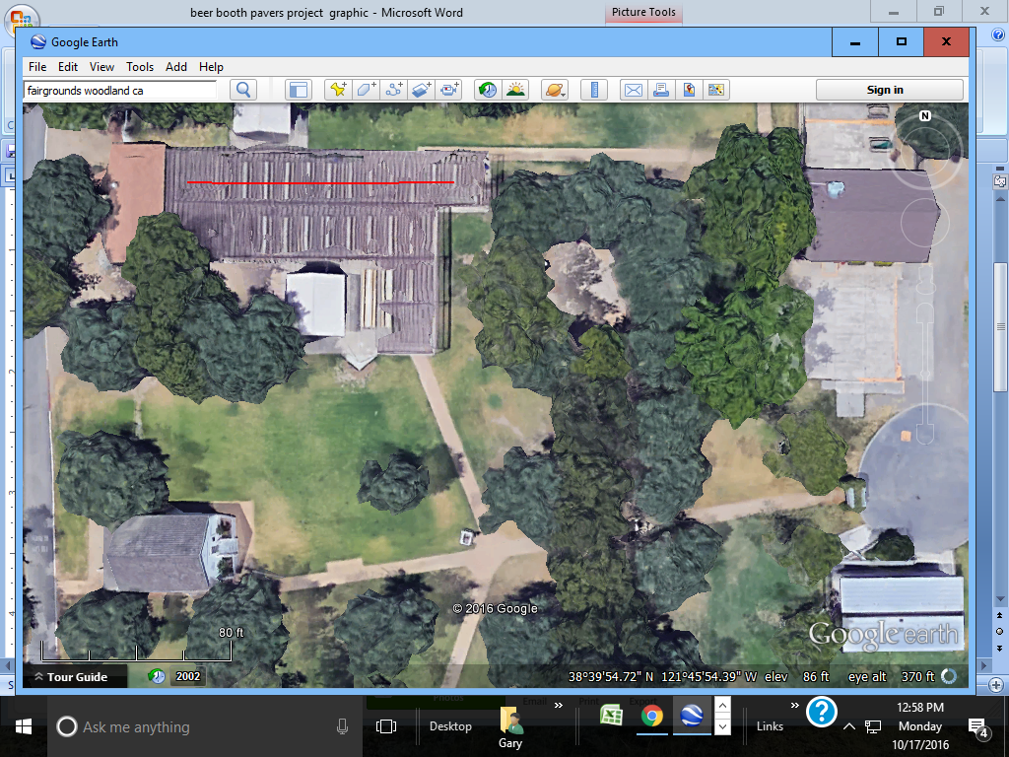

**Shade Structure**

100 ft

[Type a quote from the document or the summary of an interesting point. You can position the text box anywhere in the document. Use the Text Box Tools tab to change the formatting of the pull quote text box.]

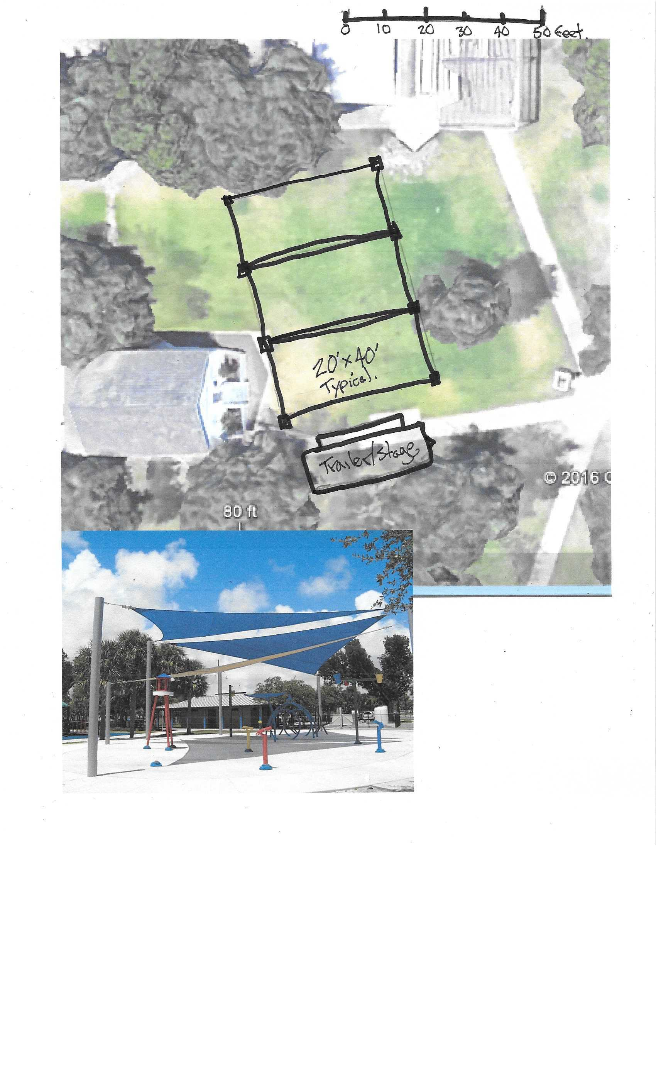

Conceptual of a shade structure for the entertainment area at Rotary Park.

SWAG cost est in $15k range

Possible District Grant project

Outyear Proect