Yolo Rotary Clubs’ Annual Berryessa Social
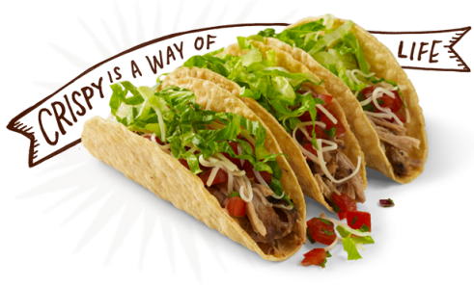
Tacos & Wine

What: The Yolo Rotary Clubs’ Annual Social at the Barryessa Gap Winery

Why: Why not? You shouldn’t have to ask!
Helloooo……Tacos, wine, Rotarians and laughing

When: Thursday evening, April 30th from 5:30 – 8:30pm

Where: Berryessa Gap Winery
27260 Highway 128 just “outside” Winters

How Much, you ask?

$25/person and that buys you 2 glasses of wine (water and soda) and buffet dinner by Sacramento’s Best Tacos

Of course, extra wine is available for purchase.

How to get on the list??

- Have your members email me to sign-up. May pay at the door.

- Keep a list and send to me NO LATER than Friday, April 24th.
Your Club may send one check to cover your group or however you choose.

The rule is….once signed-up, considered yourself obligated for the $25/person.
duh, this is because we have to pay the caterer.

Gretchen Peralta, Davis Sunrise Rotary
gperalta@dcn.org
530-304-9983

