Yolo County Fair Beer Booth Committee meeting of 18 March, 2019 5:30 pm at Steve’s Pizza.

Agenda:
- Thanks and congrats to Dean and all who worked on the paver project. Instead of 'Beer Booth' we can now refer to the area as the "Beer Emporium". Good job!!!
- Financial Report $3659 in the bank. Jacque Bartholomew
- Attached is an update given to the Area Presidents meeting March 11. It included a discussion of the website for the Beer Booth Committee (please bookmark it/check it out before our meeting http://www.woodlandrotary.org/BeerBooth.cfm )
- Future Projects: Shade structure and area lighting, several years out.
- Committee membership: need to confirm who the club reps are, both now and for the upcoming year (supposed to always have at least one that is a carry over from the prior year). We would like to reduce email group address list to the committee members and the club president and president elect.
- Discussion on the Beer Booth Guidelines
  - Background: provides common sense structure and more transparency in operations, club approval of the holdback on net profits,
  - Issues: annual election of 'officers', extension of 5% holdback (only approved for three years/expired in 2018), need to follow the guidelines (again, common sense).
  - bring your issues, suggestions
- Nomination of officers (Chair, three Co-Chairs, Secretary, Treasurer). Nominations from committee members are open, however the Chair/Co-Chairs have the following recommendation. (Should we vote on the 18th, or at a subsequent meeting?)
- Chair: Joe Muller (Woodland Luna Vista-give Dean a well deserved respite)
- Co-Chairs:
  - Dean Labadie (West Sacramento-short respite);
  - Gary Wegener (Woodland Noon);
  - Al Aldrete (Woodland Sunrise),
- Treasurer: Jacque Barthalomew (Davis Noon)
- Secretary: Candace MacPherson (Davis Sunset).
8. Next meeting Monday March 25th??:
Should have set of guidelines that incorporate proposed changes, to vote on.

March 11, 2019 Beer Booth Committee Update for the Area Presidents’ Meeting
:
The Beer Booth Committee Guidelines approved by the Club Presidents of the respective Yolo County Rotary clubs in 2015 specify that the Chair, Assistant Chair, Secretary and Treasurer will be nominated/elected each year by the Beer Booth Committee members in Jan each year. Elections are planned for late March/early April this year.
The Guidelines state that 5% of each year’s net profit will be held back in a reserve fund for future projects and expenditures in excess of $200 requires a committee vote. The 5% holdback was approved for a three year period, with a stipulation that it would be revisited in 2018 and the guidelines amended as deemed appropriate at that time. Recommendations on extending the holdback and other modifications to the guidelines will be developed for consideration/vote by the Committee (after consultation between Club Presidents and Committee members as per the guidelines). The next (last?) anticipated improvement projects include lighting and a shade structure for the seating area in front of the band stand trailer location.
The following is a summary financial report back to 2015 when the reserve concept was implemented.
Funding to Clubs Rotary Park Project Funding
 | income | expense | Gross Proceeds | less 5% reserve | total to clubs | 5% reserve | tips | Total | project expenses
2015 | $87,784 | $50,819 | $36,965 | $1,848 | $35,100 | $1,848 | $1,498 | $3,346 | $0
2016 | $87,187 | $48,533 | $38,654 | $1,933 | $36,900 | $1,933 | $1,254 | $3,187 | $0
2017 | $87,029 | $51,534 | $35,495 | $1,775 | $34,000 | $1,775 | $1,007 | $2,782 | $0
2018 | $98,093 | $55,814 | $42,279 | $2,114 | $40,000 | $2,114 | $1,346 | $3,460 | $10,250 | pavers
 |  |  |  | total | $146,000 | total |  | $12,775 | $10,250

A Beer Booth Committee webpage (see next page/link below) was initiated in 2015/16 as a repository of information related to the committee operations, including committee member directory, committee positions, contact information, the Operating Guidelines and Procedures, meeting agendas, minutes, and financial reports. It is accessible at http://www.woodlandrotary.org/BeerBooth.cfm It is in the process of being updated . Direct suggestions/questions to Gary Wegener 530 908 4914
Pending Committee Meetings.
March 18th: Stress transparency in what we do. Post meeting agendas and minutes; better financial reporting; better definition, approval process and reporting on projects. Review, update, and follow the committee guidelines. Confirmation of committee members. Nominations for committee positions (Chair, Co-chairs, secretary, treasurer, webmaster, subcommittee members).
8 April: Election for committee positions. Discuss plans for August fair beer booth operation (need for delegating responsibilities) and suggested changes to Guidelines.

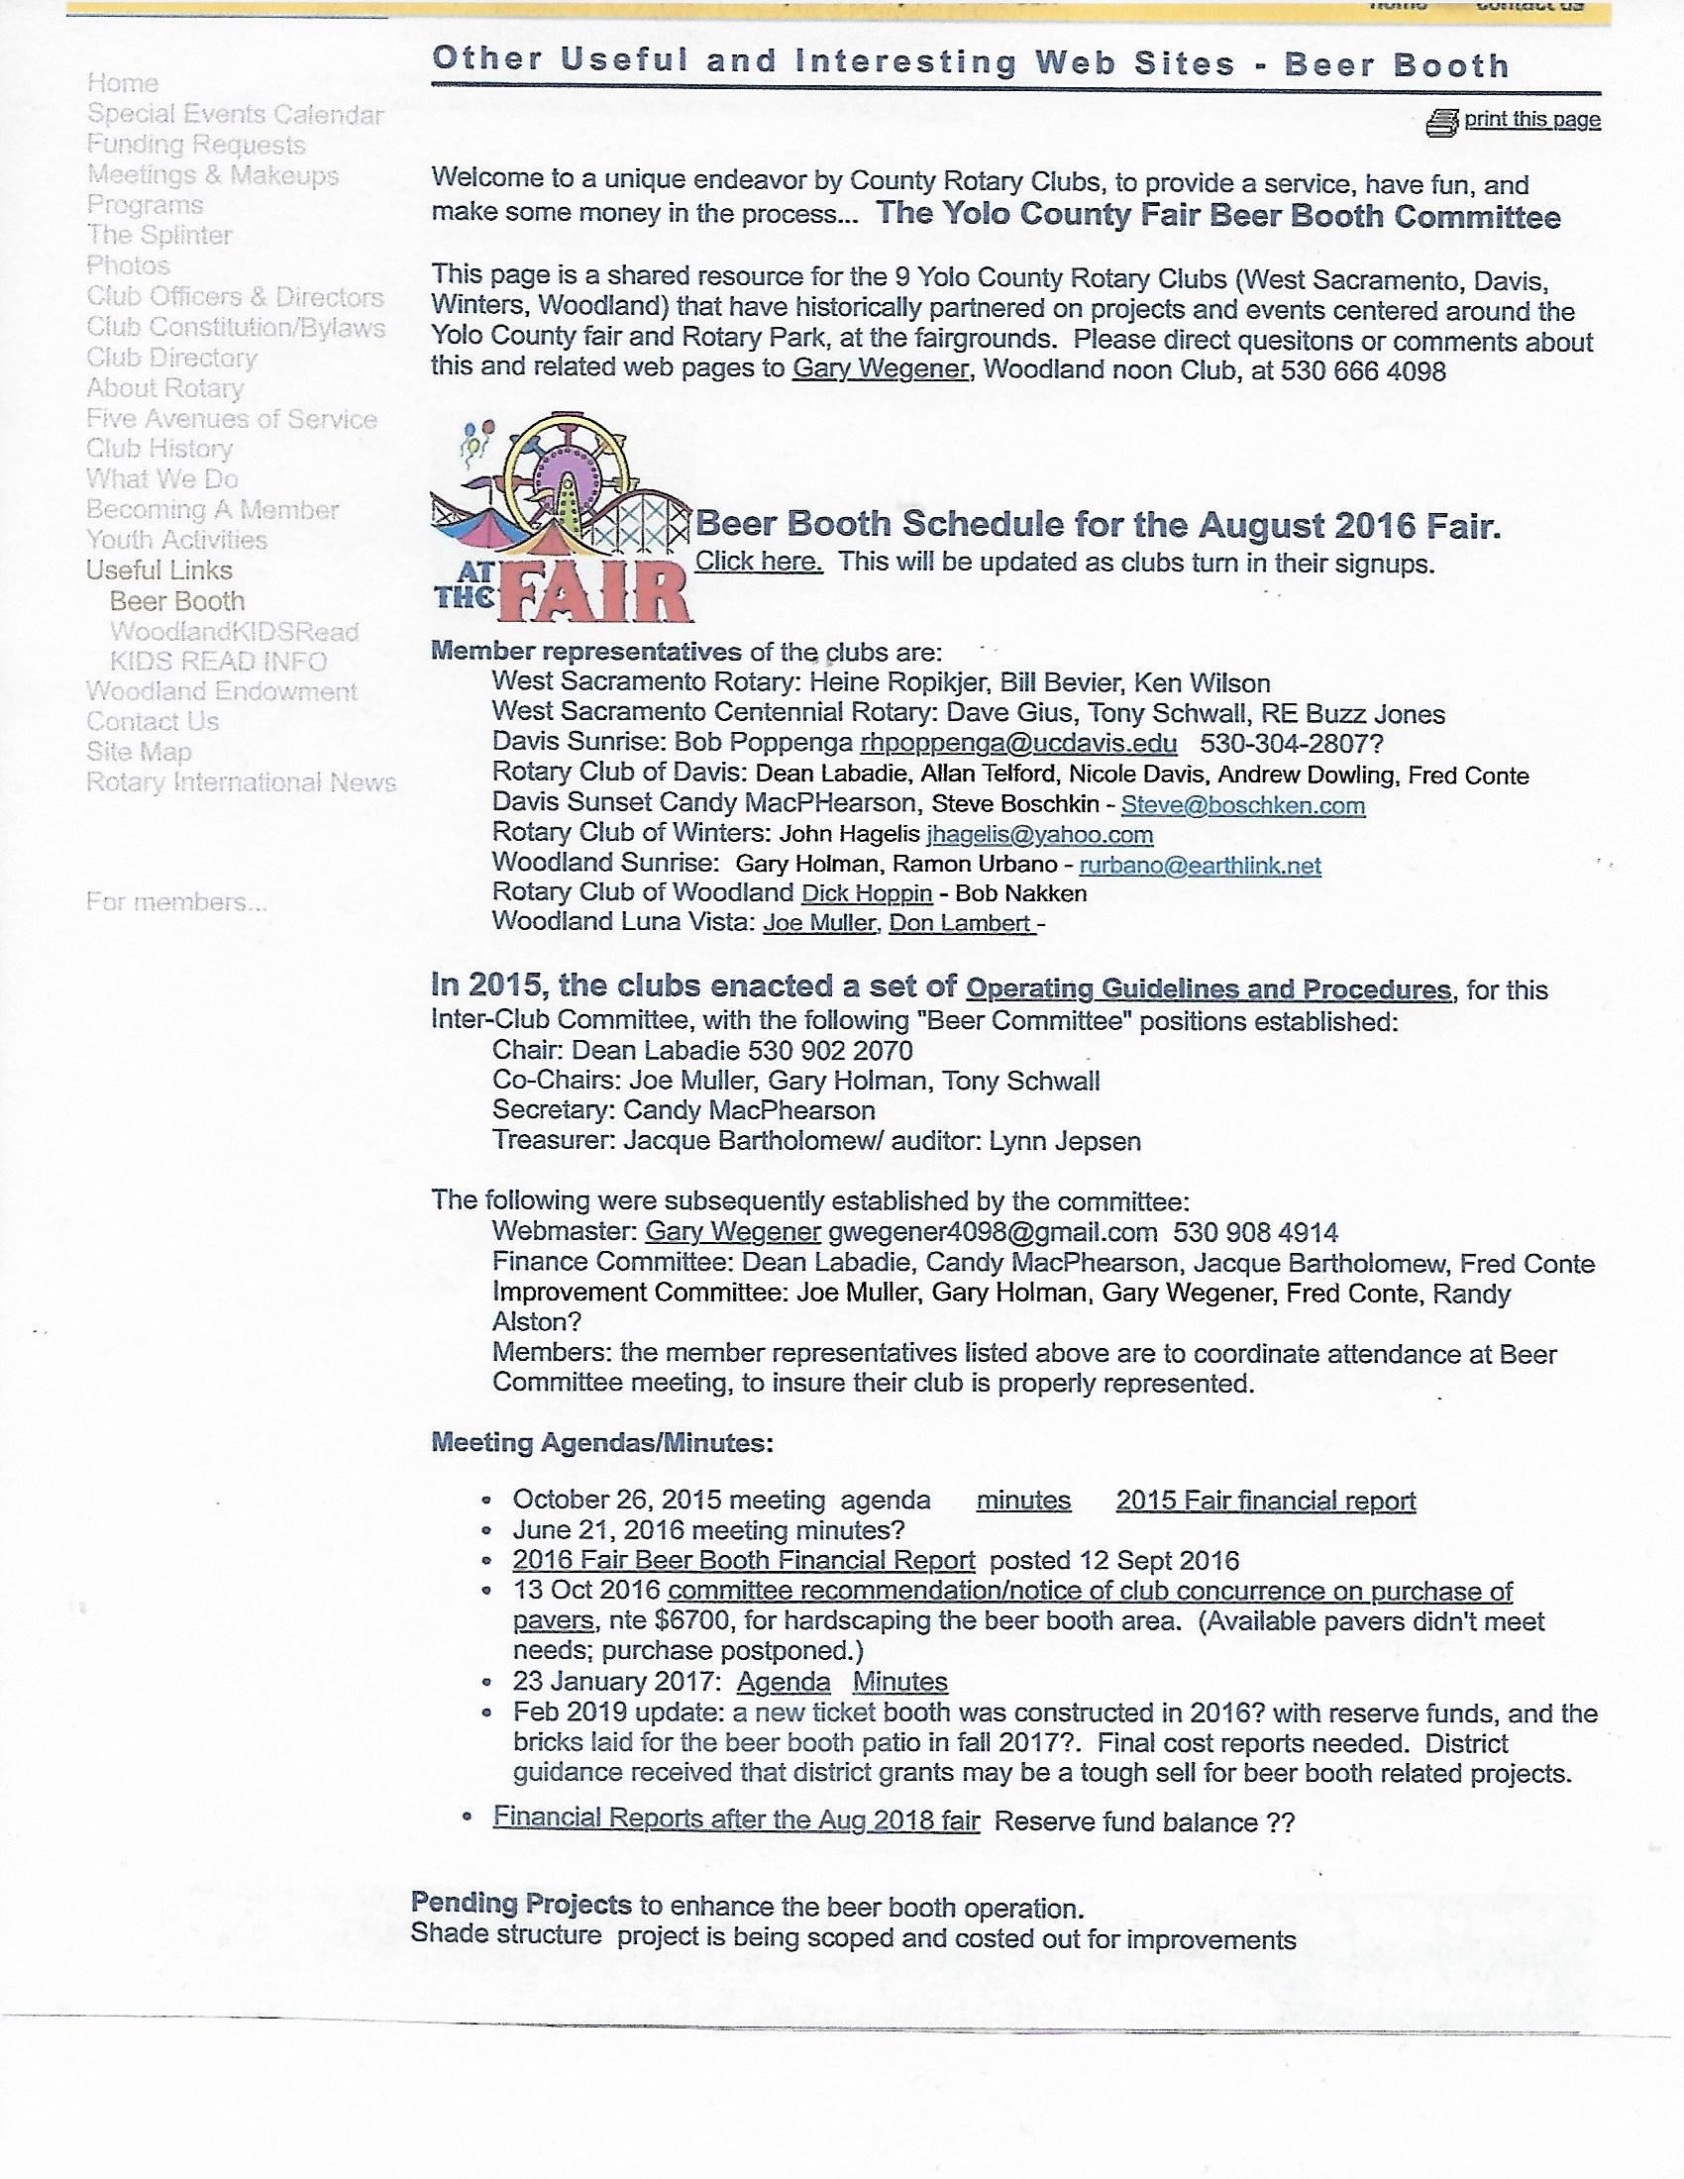
http://www.woodlandrotary.org/BeerBooth.cfm

