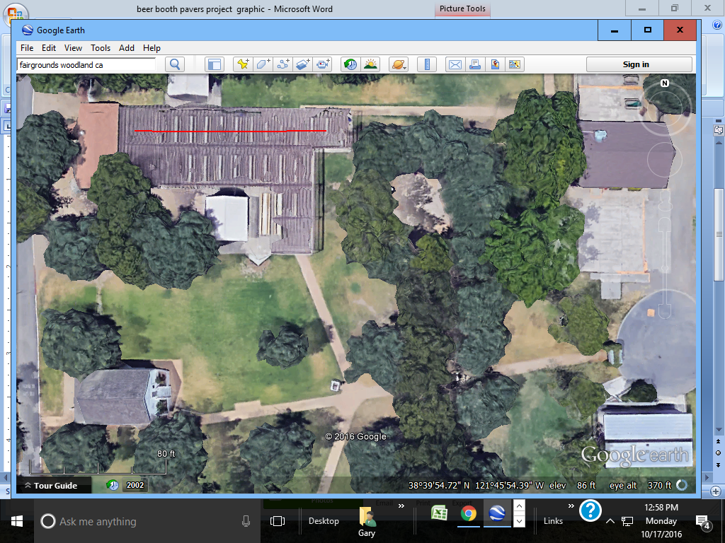

**Area Lighting Project Concept**

100 ft

[Type a quote from the document or the summary of an interesting point. You can position the text box anywhere in the document. Use the Text Box Tools tab to change the formatting of the pull quote text box.]

Area lighting for the beer booth area.

This project is totally conceptual at this stage, but is envisioned to provide permanent lighting for evening events. No estimated price has been developed yet.

Outyear Proect