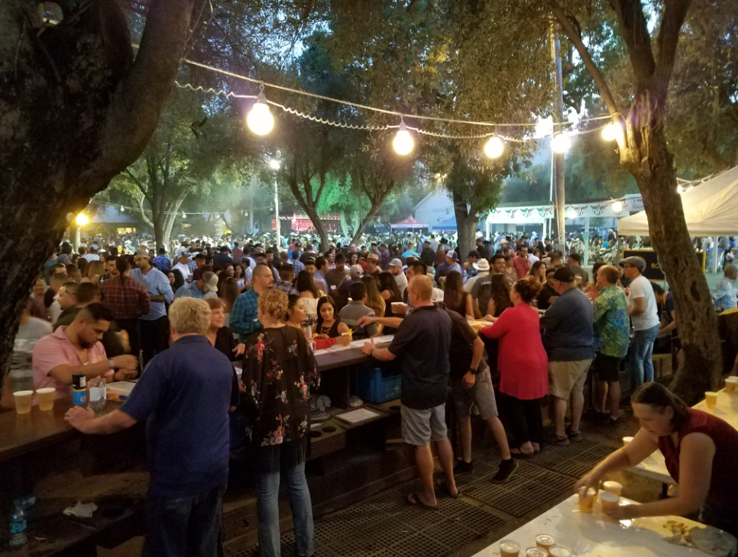

Fair Beer Booth Committee Minutes for 15 April, 2019 5:30 pm at **Steve’s Pizza**, 314 F St, Davis.

The meeting started at 5:30. Clubs Represented/members present included:

Gary Wegener, Chair Woodland; Co-Chairs Jeff Kowes, Davis; Al Aldrete, Woodland Sunrise; Joe Mulller, Woodland Luna Vista; Committee members Tom Engle, W. Sac Centennial; Ken Wilson, West Sacramento; Cecil Padilla, Winters.

1. The minutes of the March 25h 2019 meeting were approved.
2. We discussed the allocation of slots for the fair; Gary to send out a spreadsheet for consideration at a future meeting. Intent will be to have a lead person handling the scheduling, and tracking attendance.
3. Gary will contact Vicki Faye regarding Treasurer position. (This happened 4/16, she agreed, and we are setting up a meeting with Jacque Bartholomew to turn files over. Intent will be for Gary and Vicki to be the authorized signers, with written procedures on financial operations.)
4. Next, the discussion was on lead persons for the major functions of the committee.
   1. Cash management during fair. Al Aldrete agreed to take this responsibility. Also ticket monitoring?
   2. ABC permit; Al Aldrete??
   3. Joe Muller will lead the setup and take down, before/after the fair.
   4. Joe Muller will insure proper setup/supplies, limes/oranges/towels for each day, and close up at night during the fair.
   5. Joe Muller??? will oversee the keg tapping operation, training others to assist.
   6. We need a lead person for present/available for each day of the fair (may need to train folks).
   7. Need lead person for selection and procurement of the beer, and of the wine…
5. Next meeting date 13 May, 5:30 at Steve’s Pizza, 314 F St, Davis
6. Adjourned at 7 pm.

Reminder: Bookmark the Beer Booth Committee webpage: <http://www.woodlandrotary.org/BeerBooth.cfm>