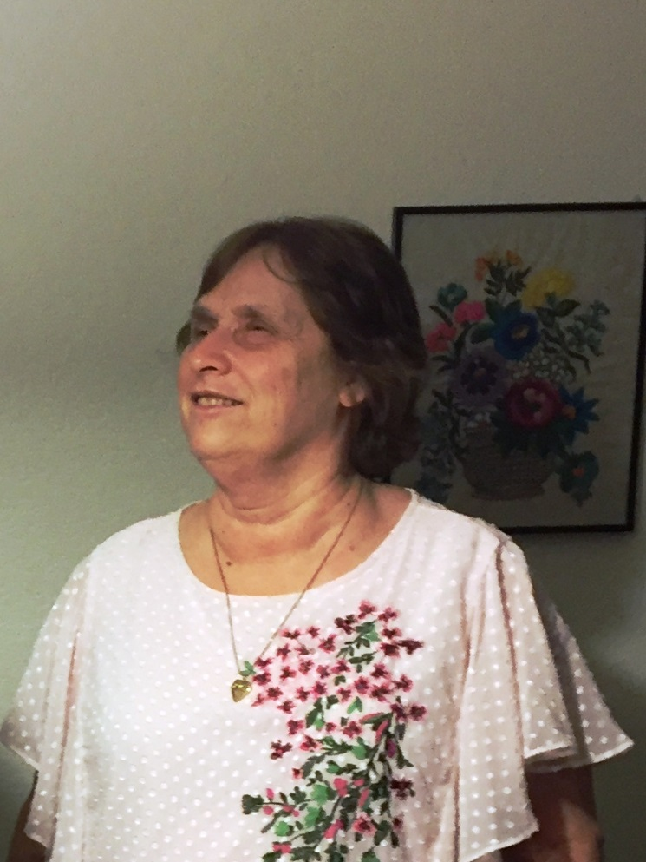

"A Life in Tune:  Music, Joy, Blindness,"

Faye Abbas started playing piano when she was three years old. She began giving vocal and piano concerts at the age of fifteen. She has lived in Woodland, CA since 1991, and is the proud mother of two sons, two beautiful daughters-in-law and three beautiful granddaughters. She has been teaching voice and piano for over forty years. Her students regularly appear in productions at the Woodland Opera House

Originally from South Carolina, she lived in Nashville for five years, where she released her first recording. Faye has traveled extensively throughout the United States, as well as overseas. She received her Bachelor of Music degree from Furman University in Greenville, South Carolina. She also holds a Master's in Church Music with emphasis on vocal performance from the Southern Baptist Theological Seminary in Louisville, Kentucky.

In addition to her responsibilities as a private music teacher, she is very involved in the music program at her church.

Copyright 08-26-2025 Faye Abbas music Studio