**Signage requirements for the beer booth area:**

|  |  |  |  |  |
| --- | --- | --- | --- | --- |
| page | Description | Number of 8.5 by 11 | Number of 12 by 18 |  |
| 2 | Shift supervisors | 1, on beer trailer, facing back of bar | 1, in Ticket Booth. Visible to customers |  |
| 3 | By order of the state…  One for ABC permit and one for health dept permit. | 2 in beer booth east wall, visible to customers |  |  |
| 4 | Drink responsibly, reserve the right to refuse. |  | 2, around the paver area |  |
| 5 | Liable for serving underage | 2. One in ticket booth, one extra. |  |  |
| 6 | Liable…underage. Problems call: | 2. One in ticket booth, one extra |  |  |
| 7 | Drink responsibly, Uber/Lyft/taxi |  | 2, around the paver area |  |

**Questions, call Gary Wegener, 530 908 4914**

**Yolo County Fair Rotary Park Beer Booth**

**Chair Tom Richardson 530 906 8393**

**Shift Supervisors**

**Wednesday 6-10pm Tom Engle 916 799 5556 (RBS)**

**Thursday noon to 6pm Rich Marovich 530 902 1794 (RBS)**

**Thursday 6-11:30 pm Tom Wendt 530 4433 (RBS)**

**Friday noon to 6pm Rich Marovich 530 902 1794 (RBS)**

**Friday 6 to 11:30pm open till filled (others RBS certified)**

**Saturday 11am to 6 Linda Hart 530 220 2515 (RBS)**

**Saturday 6 to 11:30pm David Gius 916 997 7093 (RBS)**

**Sunday 11am to 6pm Tom Richardson 530 906 8393 (RBS)**

**Sunday 6pm to 11:30 Woody Fridae (Others RBS certified)**

**By order of the State of California**

“1 with the ABC permit and 1 with County Environmental Health Permit”



**Drink responsibly.**

**We reserve the right to**

**re-card/refuse service to anyone.**

**Ticket booth closes Wed at 10:00pm, Thu-Sun at 11pm**

**Serving stops Wed at 10:30pm, Thu-Sun at 11:30pm**

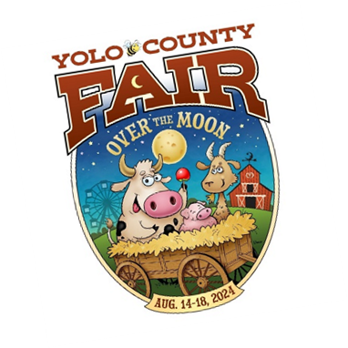

**A maximum of only two alcoholic beverages can be dispensed per person, at one time.**



Remember…

**We are liable for serving under age customers**

Refer questionable IDs to Beer Booth Supervisor. Supervisor may refer to law enforcement.

We have an obligation to check, recheck ID’s if in doubt.

**We are liable if serving customers that are intoxicated**.

Remember SCAB: **S**peech **C**oordination **A**ppearance **B**ehavior

(Just say, I am not comfortable serving you/offer to refer to law enforcement. **We are responsible for assisting, helping and protecting customers**

(this requirement may be met by notifying law enforcement)

How are you doing? Refer to law enforcement)

**We are stuck if we accept Counterfeit Bills.**

See posted info on detecting counterfeit bills.

Use the “detector” device in the booth.

We debated not accepting $100 bills, but opted to double check them instead.

Take your time; we are under no obligation to accept them. And the counterfeiters are good.

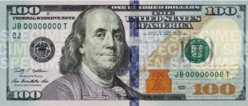 If you think you have one, Shift Supervisor should contact law enforcement.

The money courier is only one that can take money out of the ticket booth.

No trading denominations of bill with other vendors; too easy to miscount.



Remember…

**We are liable for serving under age customers**

Check ID’s before wrist banding; refer questionable IDs to Beer Booth Shift Supervisor. Refer issues to shift supervisor, who may refer to law enforcement.

**We are liable if serving customers that are impaired/intoxicated**.

Remember SCAB: **S**peech **C**oordination **A**ppearance **B**ehavior

(I am not comfortable serving you/refer to law enforcement)

**We are responsible for assisting, helping and protecting customers**

(this requirement may be met by notifying law enforcement)

Problems, call:

Shaun Morrow 916 402 0770 is the “resident expert” for the beer kegs.

Dan Stroski is courier 530 723 2246

Rotary Beer Booth Chairs Tom Richardson 530 906 8393 Assist Gary Wegener 530 908 4914

Yolo County Sheriff. Command Center # ______________

Fair office (Caroly Guillen 530 402 2204)

Ice #_____________________

CO2 cylinders Blair Voelz. 530 681 1144

**Drink Responsibly**

Know your limit.

Don’t Drink & Drive.

Use Urber/Lyft

