

December 1, 2024

Becoming a Host Family

As the current Inbound Coordinator for District 5160’s Youth Exchange Program, part of my job is to help place the world’s best youth with the world’s best host families. I want to share my story with the disclaimer that I absolutely intend this to cultivate new host families for future YEX student placement.

While attending a weekly Rotary meeting in October of 2014, I sat down next to a delightful young lady who was a visitor. We struck up a friendly conversation, though I was completely unaware that she was an exchange student in need of a host family. As is common, when the meeting started, we acknowledged visiting Rotarians and then guests of Rotarians. It was here that she stood with her Counselor and told us about the problem. Her first host family just could not, for personal reasons, continue as her host family. My hand could not go up fast enough!

Jasmina was a sixteen-year-old student from Bad Durkheim, Germany. She moved in with me and my wife two weeks later and fit right in. She lived with us for 9 months. She attended Pioneer High School and joined their track team. We took her to Disneyland, San Francisco, and San Diego to see the California sites. When school was over, she waited until the very last day (30 days) before she had to go back to Germany. It was sad to see her leave, and tears were flowing. What I did not expect was the frequent return visits: Christmas, my 60th birthday and assorted family holidays. Each one a surprise and with the specific intent to make me cry! She remains an integral part of our family. We have been to Germany to meet her family and if her little sister wants the same experience, we intend to do it again.

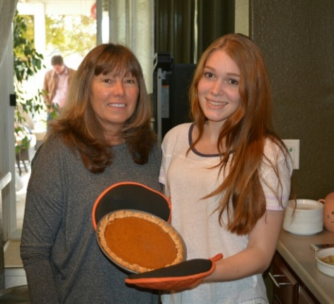

In the fall of 2018, we became the host family to Andy from Beijing, China. Because of Covid his stay was extended since travel back to China was not possible. Here is his version of the story:

“As an international student, my study abroad journey has been full of warmth and meaning because of my host family. During my four years of high school, Dan & Ginny Stroski opened their home to me and treated me like part of their family. They made me feel at home even though I was thousands of miles away. Living with them was not just about sharing a house, it was about sharing our cultures, ideas, and traditions. Even though we came from completely different countries and backgrounds, we built a strong connection based on respect and understanding.

This experience gave me a deeper appreciation for the beauty of different cultures. Dan also took me to many memorable activities, like attending Rotary Club events and visiting Disneyland. These experiences helped me learn more about American culture and feel like I was part of the community. During the pandemic, when the U.S. faced a shortage of masks, I asked my parents in China for help, and together we donated masks through Dan's Rotary Club to support the local community. This was not just about helping each other as families—it was also a symbol of friendship and kindness between two countries.

Living with Dan and Ginny not only helped me grow, but it also brought something new to their lives. We built a bond that went beyond borders and became a lasting friendship. All of this happened because they were willing to welcome an international student into their home.

Becoming a host family is not just about giving someone a place to stay. It is about sharing experiences, building connections, and changing lives—both theirs and yours. By opening your home, you are not just welcoming another student, but a lifelong friend, a new family member, and a lifelong bond.”

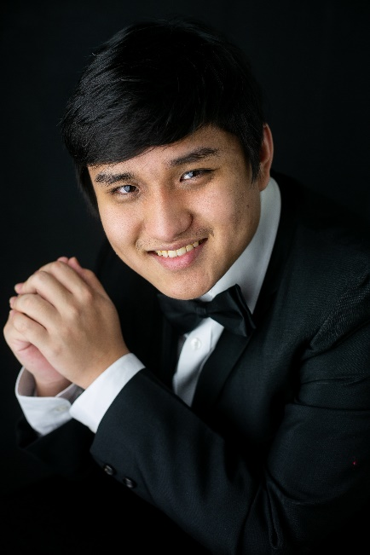

There were differences in terms of the length of time the students were with us, but for both the experiences were worth the time and effort necessary to give these children lives they will never forget.

So now you’re interested in hosting? e-mail Dan Stroski at [dstroski@aol.com](mailto:dstroski@aol.com)