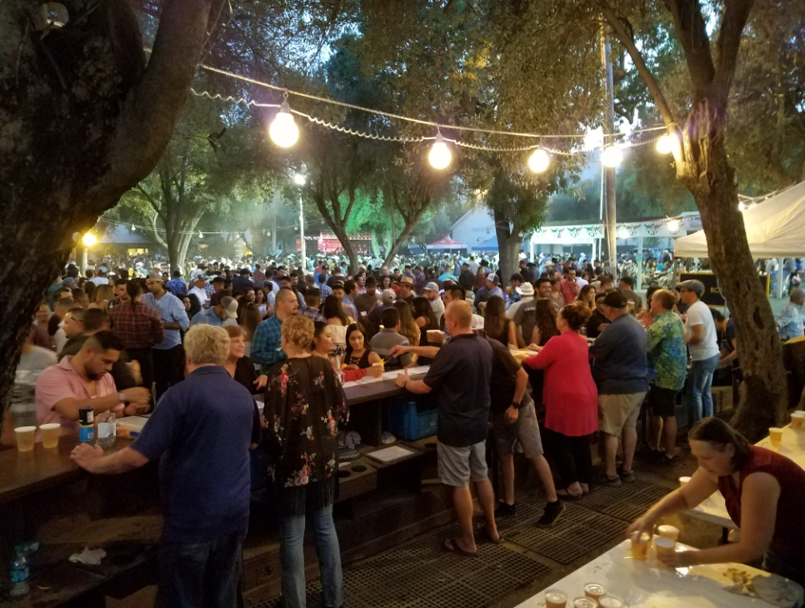

Fair Beer Booth Committee Agenda for 25 March, 2019 5:30 pm at **Steve’s Pizza**, 314 F St **In DAVIS**.

1. Committee membership (can you confirm this is correct for your club?):
   1. Clarksburg Kathy Turner, Josh Kriess
   2. Davis: : Jacque Bartholomew, Treasurer; Jeff Kowes Co-Chair; Andrew Dowling
   3. Davis Sunrise: Bob Poppenga, Steve Boschken
   4. Davis Sunset: Candace McPhereson Treasurer
   5. West Sacramento Dean Labadie Co-Chair; Shaun Morrow, Ken Wilson
   6. West Sacramento Centennial: Tom Engle
   7. Winters: Cecil Padilla
   8. Woodland: Gary Wegener Chair; Dick Hoppin
   9. Woodland Sunrise: Al Aldrete Co-Chair; Gary Holman
   10. Woodland Luna Vista Joe Muller Don Lambert
2. Approve minutes of March 18th 2019 meeting (attached).
3. Recommend approval of the following change to the Guidelines:
   1. Add to Article 5: “The 5% holdback for the Reserve Fund shall be extended three more years (to expire in 2021)” This is necessary because the guidelines state the 5% hold back was only initially approved for a 3 year period, ending in 2018. Not having the 5% extended before this fair send a wrong message. It’s felt best to deal with the 2018-19 Presidents group before the end of their term, than try to squeeze it in before the fair with next years Presidents.
   2. Additional changes will be brought to the Club Presidents when there is more time to develop/review them recognizing that may also take more review time at the Presidents’ level.
4. Reports:
   1. Meeting 21 March btwn Bart Vannucci Fair CEO, and Gary Holman Fair Board member, and Gary Wegener, and Joe Muller.
      1. Fair music programming for Sunday evening has been brought in house.
      2. We’re welcome to meet w/ Marty, the fair’s entertainment coordinator to discuss ideas
      3. Bart reiterated he was fully supportive of our Sunday programming focus and there was no discussion of changing that.
      4. We talked about ways to enhance the bar operation and possible improvement projects (Ron, the Maint. Supervisor, would be an initial point of contact to review ideas with).
   2. Jacque has indicated she would like to turn over the Treasurer’s duties and Dean has indicated a similar desire. Am confirming Candy’s interest as secretary. Any nominations???
5. Dean’s Procedural Manual; see attached. Comments on organizing for the next fair???
6. Beer Booth Committee Website: <http://www.woodlandrotary.org/BeerBooth.cfm> Please add the link on your website to facilitate your clubs access.
7. Other questions, concerns, discussion??
8. Adjourn (next meeting date____________?? Location _________________??)