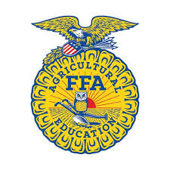
Yolo FFA Sectional Opening & Closing Contest
FFA is currently looking for generous volunteers to serve as judges for our Sectional Opening & Closing Contest:

This sectional contest will be held on Friday October 27, 2023, at Woodland Community College. Registration will be held in the 800 room (Community Room) on campus. School teams coming from Woodland High School, Esparto High School, Davis High School, Delta High School, Winters High School, Woodland Christian, River City, and Pioneer High School and have been working hard preparing for this annual event.
You will see and judge our middle school teams, our inquiring freshmen teams, our developing advanced teams, and our polished officer teams during this incredible day's event. We hope you will join us and save the date, Friday October 21, 2023!!
The itinerary of the day is as follows:
8:30 am = Arrive & pick up judge’s packets in room 800 at Woodland Community College
8:30-8:45 am = Meet with other judges and review materials/develop questions/strategy in contest room (enter community room, we will have coffee and breakfast waiting for you!)
9:00 am = Contests begin
12:00 pm = Contests conclude (time varies depending on the number of contestants and the contest) Lunch will be provided to you.
1:00pm = Awards
Contact Brandi Asmus <basmus@gmail.com> to become a judge.

Chuck Moore can answer questions.

