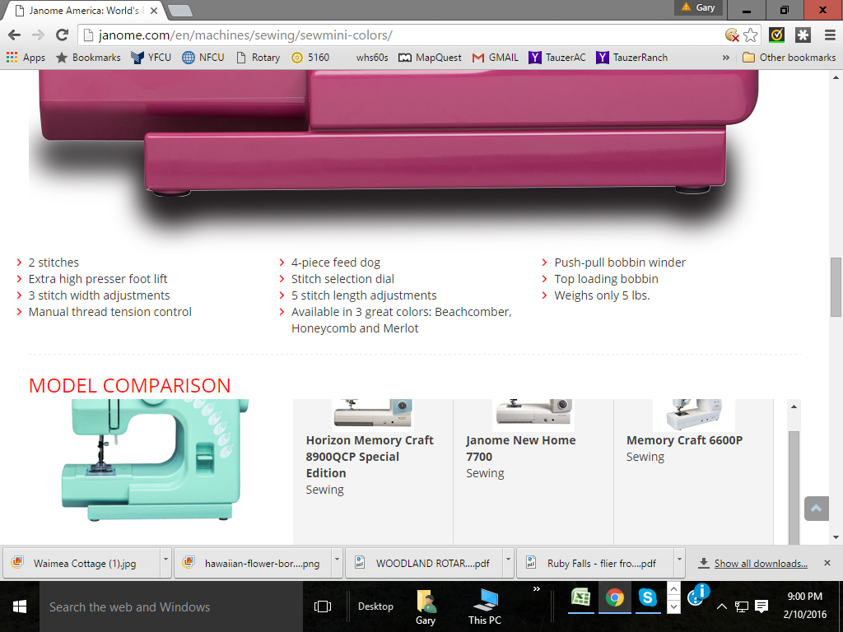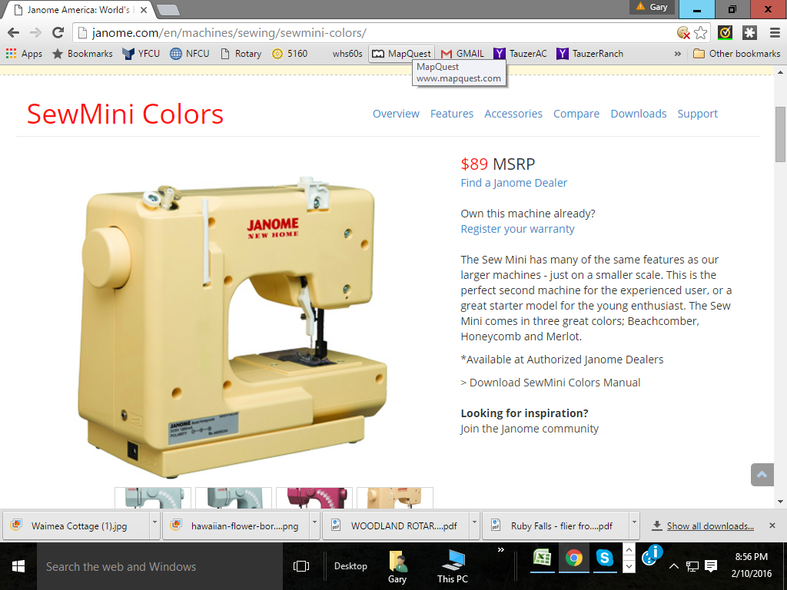**Silent Auction donation from Woodland Sewing and Vacuum Center**

**Silent Auction Donation from Hiromi Diekman**

**Fresh Water Pearl Necklace**

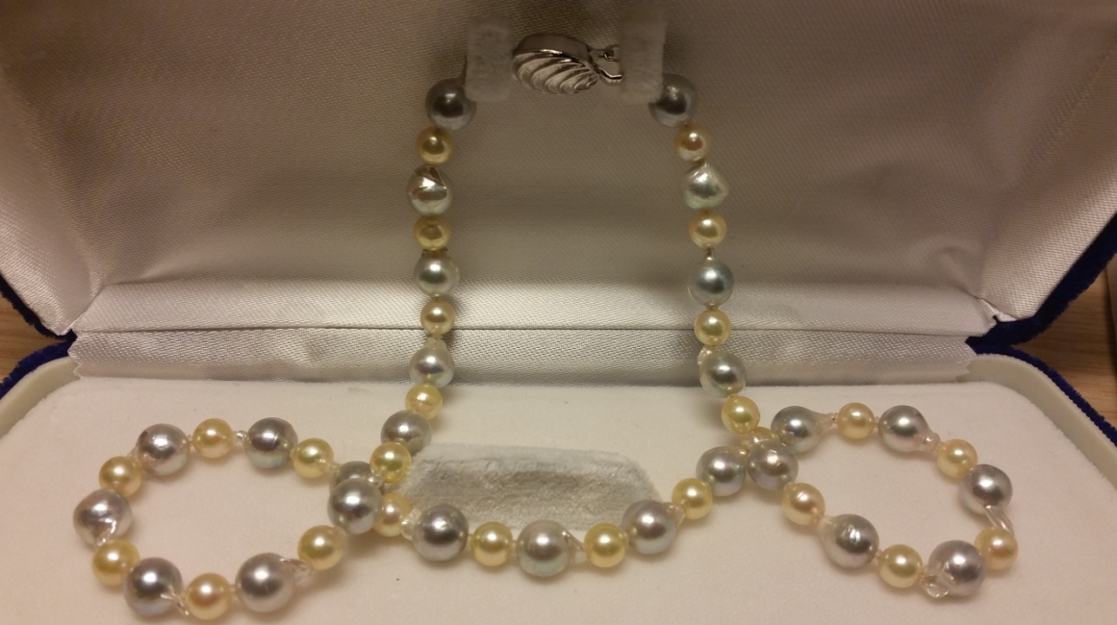A beautiful 18 inch freshwater pearl necklace with a fancy Sterling Silver (925) clasp. This unique necklace is composed of 5.0-7.0 mm freshwater pearls in alternating colors of light grey and beige freshwater pearls. Valued at $190.

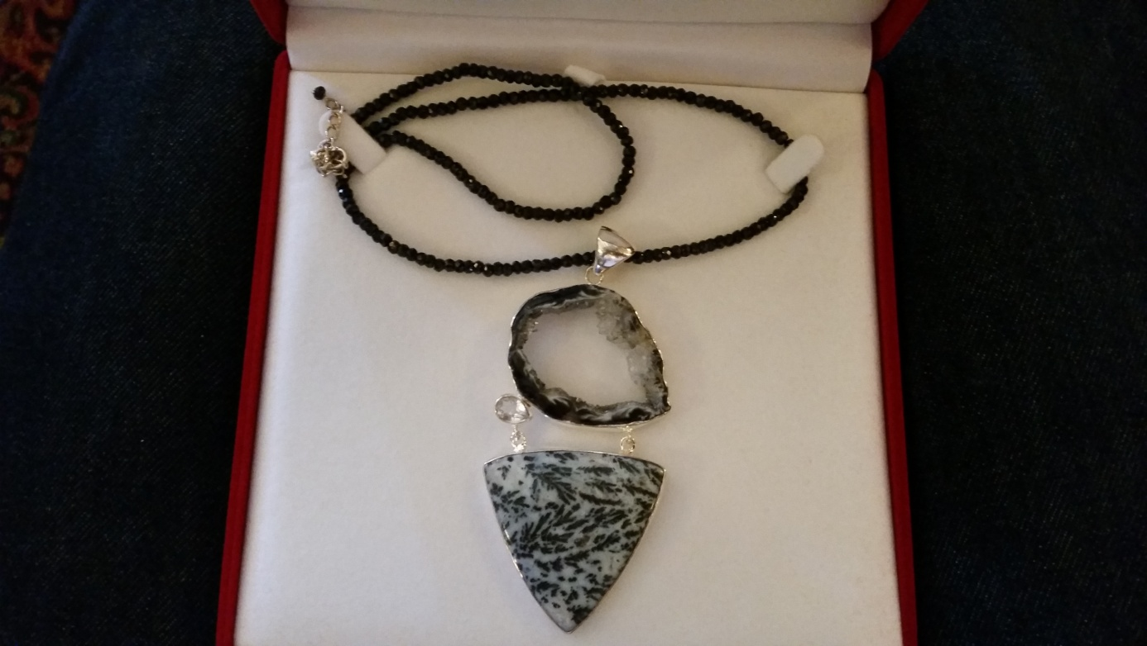

**Silent Auction item donated by Dave Flory**

**Stone Necklace, valued at $250**

**Silent Auction Item, donated by CostCo**

**Fireplace Media Console, valued at $549**

55” long, 19” deep, 42” tall

5200 BTU, 1500 Watts

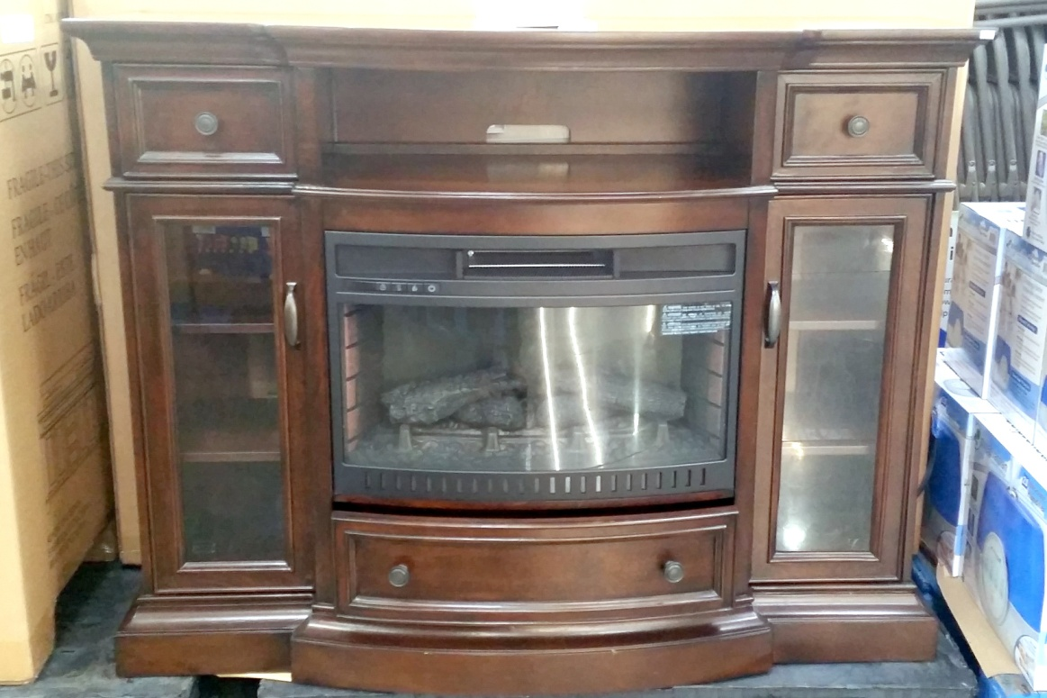Poplar solids, Beech veneers

Center media shelf

Remote Control